**Integrated System for Sustained Community Engagement: Enhancing Collaborative Initiative Across Departments at Pamantasan ng Lungsod ng Pasig**

A Capstone Project presented to the

College of Computer Studies of

Pamantasan ng Lungsod ng Pasig

In partial fulfillment of the requirements for the degree of

Bachelor of Science in Information Technology

by:

Mendoza, Kurt Andrei T.

Ramos, Jennylyn Anne O.

Recopuerto, April Juliana C.

Noreen A. Perez, DIT  
Adviser

November 2024

**CHAPTER I**

**INTRODUCTION**

**1.1 The Problem and It’s Background**

Garay et al. (2021) examines the sustainability of Arellano University's College of Arts and Sciences community extension activities in Barangay Masalipit, Bulacan. The study finds that programs in literacy, wellness, environment, and behavior have lasting positive impacts on the community, while initiatives like Legal Awareness and the History Society need improvement. The research emphasizes the importance of maintaining these activities for the community's dignity and self-sufficiency. For Pamantasan ng Lungsod ng Pasig, integrating a system to monitor and enhance these activities can ensure long-term community engagement and success across different departments.

Corpuz et al. (2022) explore the effects of extension services by the College of Teacher Education at Nueva Vizcaya State University. Using a descriptive survey and structured questionnaires, they highlight active community participation in Projects HELP and KKK, despite challenges like sporadic consultations and irregular monitoring. The study shows a generally positive impact on the community. Applying a similar structured approach at Pamantasan ng Lungsod ng Pasig can help address minor issues and improve the efficiency of extension programs, fostering better collaboration and community acceptance.

Maring et al. (2023) examine the development and importance of agricultural extension programs, which were designed in the 20th century to promote agricultural growth by educating farmers on new technologies, production techniques, input usage, and management strategies. The study emphasizes the crucial role of Monitoring and Evaluation (M&E) in assessing the effectiveness of these programs. M&E provides ongoing feedback and evaluates program impacts, aiding in decision-making, accountability, and policy adjustments. The three M&E methods discussed result or outcome driven, constructivist, and reflective approaches facilitate continuous improvement and problem identification for remedial actions. For Pamantasan ng Lungsod ng Pasig, implementing a robust M&E system can enhance the effectiveness and impact of community engagement initiatives, ensuring continuous improvement and successful collaboration across various departments.

Koekkoek et al. (2021) review the global trend of university-community engagement, identifying critical gaps in current research and practices. They advocate for filling these gaps through empirical evidence, theoretical debates, and specific research methods. For Pamantasan ng Lungsod ng Pasig, addressing these gaps can lead to a more comprehensive understanding and execution of community engagement strategies, fostering a holistic and effective system that benefits both the university and the local community.

Magnaye et al. (2021) evaluate the community extension programs of a Philippine university, finding that livelihood and entrepreneurship initiatives had the most significant impact. Other programs, such as environmental efforts, health services, and computer literacy, were less effective. The study suggests that enhancing these programs through targeted strategies can improve their impact. Implementing these findings at Pamantasan ng Lungsod ng Pasig can help optimize the effectiveness of various community engagement activities, ensuring sustained positive outcomes and fostering greater collaboration across different departments.

Pamantasan Lungsod ng Pasig (PLP) is a renowned educational institution dedicated to education and community development. Its Community Extension Service (CES) plays a critical role in various outreach programs connecting the university with local communities. However, CES faces significant data management challenges due to its reliance on Google Drive for document storage and sharing, which is inefficient for large volumes of data, and on Microsoft Excel for data entry and manual verification processes, leading to mistakes and inconsistencies. While Google Drive facilitates real-time collaboration and Excel aids in data analysis and reporting, a tailored platform for CES would be more advantageous, integrating these functions into a single, secure interface. Additionally, CES's general workstation is unsuitable, with staff members primarily communicating via Messenger, an informal and inconsistent platform for organized and effective teamwork. The absence of a well-organized communication system exacerbates coordination issues and lowers team morale and productivity. Therefore, this research aims to build an Integrated System for Sustained Community Engagement at PLP. This system will improve community engagement through a well-organized platform for planning and collaboration, enhance communication among faculty members, streamline project management, and ensure the sustainability of community efforts. It will enable PLP’s Coordinators to track initiative progress and measure impact with real-time data, Simplify immediate corrections

**1.2 Review of Related Literature**

This chapter reviews relevant literature and studies, providing insights that will support the development of the Integrated System for Sustained Community Engagement at Pamantasan ng Lungsod ng Pasig.

**Community Extension Services**

The article by Corpuz et al. (2022), Community extension services encompass a range of activities and programs conducted by educational institutions, organizations, and government agencies to engage with local communities, deliver essential services, and promote sustainable development. These initiatives are designed to address local needs, improve quality of life, and foster meaningful partnerships between institutions and the community. The quality of these services is crucial as it directly impacts their effectiveness in meeting their objectives and achieving positive outcomes. High-quality extension services are characterized by thorough planning, active community involvement, and ongoing evaluation, all of which contribute to their success and sustainability in addressing community needs.

**Community Extension Program`**

A study conducted by Guiron et al. (2019). Education serves society by extending its expertise to individuals, groups, or communities. Universities often engage in activities known as extension services or outreach programs. Through these programs, universities, aided by their students and supervised by faculty or staff, apply their knowledge to meet the needs of specific communities within their various focus areas.

A Community Extension Program provides a unique learning experience, emphasizing practical application over theoretical knowledge. The meaning of the program can differ for each participant, often encouraging qualities like kindness and compassion towards those less fortunate. Working in groups and sharing ideas can be challenging for some students, but the program helps develop personal traits such as leadership skills, public speaking, and confidence.

**Community Outreach vs Community Services**

A study conducted by Decena et al. (2020) examines how higher educational institutions, such as Pangasinan State University (PSU), employ outreach initiatives and extension networks to positively influence society. PSU’s extension services cater to different groups, including fishermen, school dropouts, jobless persons, mothers, women organizations, and indigenous communities, as they advocate for socio-economic development and promote grassroots empowerment in terms of sustainable development. Broad-based initiatives that leverage university capacity are involved in community outreach, while specific-target group programs meant to address identified community gaps are called community services.

**Short-Term and Long-Term Community Program**

**Short-Term**

A study conducted by Asio et al. (2022). evaluates the immediate effectiveness of an institutional extension program by examining the current level of program outputs and their economic and social impacts within a local community. Using a descriptive-correlation design and SPSS for analysis, the study finds that the program outputs and impacts received "very satisfactory" ratings from respondents. The analysis also shows a moderate positive correlation between the program outputs and their economic and social effects. The investigators provided relevant recommendations for sustainability and support of the programs.

**Long-Term**

A study conducted by Magnaye et al. (2021). The university is dedicated to promoting a harmonious relationship with society as well as catering for the underprivileged members of the society. This includes, among other things, the Sotero H. Laurel Restoration Village in Barangay Sico, Batangas City which is an institutional project in partnership with Couples for Christ Family Life Foundation that hopes to give homes to indigent families. For many years, this institution has been improving the lives of people living in adopted communities. The aim of this community extension program is assisting poor people get over their challenges and start living meaningful lives independently. Hence, it should be efficient and sustainable so as to help more people benefit from it in future. Hence, it is important to assess how successful these community extension programs are towards achieving the goals set by the university. This study will endeavor to have a broader picture on how far reaching an influence this program has on those who are its beneficiaries enabling them to raise themselves on higher levels.

**Challenges of Community Extension Programs**

A study conducted by Santiago et al. (2024) In this project is how Higher Education Institutions (HEIs) can be used to enhance the development of societies through relevant extension activities. It investigated college teachers’ perspectives on why those are involved in conducting community service projects, their personal and professional motivations, challenges encountered, etc. The university has taken measures to facilitate delivery of extension services. One must therefore look for such an extension delivery system that makes possible for high technology transfer and management leading to increased profitability of the production sector. Therefore, understanding the reasons behind such practices and difficulties faced by the professors during conducting outreach programs within their locality becomes a critical tool to their success. This research was conducted in order to find out institutional, personal, and professional incentives, extent of involvement and some challenges from college teachers who were responsible for organizing local community activity.

**Sustainability**

A study conducted by Garay et al. (2021). As the outreach and extension arm of the university, Arellano University Community Extension & Development Office represents a strategy for reaching out to its surrounding communities. It primarily aims at making sure that in its chosen community, there are livelihood programs that are flourishing and able to support poor families effectively. Furthermore, this study seeks to evaluate how sustainable CAS programs can help improve the quality of life among residents in a way that they can live with dignity as well as participate in future development efforts. The research also indicates sustainability for many CAS programs such as Literacy, Wellness, Environmental and Behavioral initiatives. On the other hand, Legal Awareness and History Society need improvements or adjustments since they have been less effective than expected according to recent studies interrogated by this thesis.

**Government Extension**

A study by Mores et al. (2019) highlights the potential for collaboration between universities and local government units (LGUs) to achieve sustainable community development. However, the research often overlooks the preparedness of both sides, including factors like negotiation expectations, target setting, and problem anticipation. This study focuses on identifying the right environment, resource availability, and motivation for universities to engage in urban planning.

The University of the Philippines Los Baños has partnered with several LGUs throughout the region and the country. Local universities have the capability, resources, technology, and strategic location to facilitate local plan preparation more quickly and at a reduced cost. However, LGUs have yet to fully utilize this resource despite the rapid growth of public universities in terms of finance, enrollment, and resources. State universities are also mandated to provide extension services, which can include local plan preparation.

**Utilization of Budget**

The article of Mukaramoja et al. (2019) explores the impact of budget utilization on public expenditures in The County Government of Trans Nzoia, Kenya drawing from Budgeting Theory and Resource Allocation Theory. This study employed a descriptive survey design type and targeted 112 respondents such as internal auditors, accountants, economists, directors of departments, chief officers and finance officers. A sample size of 88 was obtained using Taro Yamane’s proportional sampling technique. Structured questionnaires were self-administered to collect data that was pilot tested for reliability and validity in Uasin Gishu county. SPSS version 24 was used to process the data while descriptive statistics were used for summarizing data through frequencies, percentages, means etc. Inferential statistics such as Pearson correlation coefficient used to determine relationships between variables include multiple regression analysis. The results are summarized in tables and show that knowing budget utilization can enable policy makers to have effective policies as well as help stakeholders achieve a proper budget execution with an aim of controlling extravagant expenditures among governments at counties levels.

**Participant's Engagement on Community Extension Program**

The study by Montebon et al. (2023). Aims to assess the impact of community extension programs implemented by a university, focusing on volunteerism and its effects on the community. The research seeks to determine the profile of volunteers, the programs and activities they want to be involved in, and the perceived changes in attitude, behavior, and lifestyle of the community. The study also evaluates the effectiveness of community extension programs and services provided by the university, including their impact on the adopted community. The quality of the extension services is a crucial factor in achieving sustainable outcomes. The research ultimately aims to present an approach to evaluating community outreach efforts and their influence on the community.

**Recommender System Machine Learning**

A study conducted by Salau et al. (2022). Recommender systems (RSs) have gained prominence as intelligent software designed to predict users’ preferences for specific items. Various RSs have been developed for different domains, such as e-commerce, e-government, e-resource services, e-business, e-library, e-tourism, and e-learning, to offer exceptional user recommendations. In the realm of e-learning technology, RSs aim to support and enhance the learning experiences of students and organizations. This survey examines numerous pieces of literature on RSs that support e-learning, categorizing and providing statistics of the reviewed articles based on their recommendation objectives, techniques employed, target users, and application platforms.

We form opinions about things we care for, like, or dislike daily. This is a common occurrence in our lives; for instance, we may decide to attend school in the morning, play soccer in the afternoon, and watch an action movie at night. Similarly, when purchasing an item from a store, one might choose a snack, an item from the dairy section, a book, or a beverage. However, making the right decision is one of the challenges people face in their daily activities. Therefore, there is a need for an intelligent system to help predict user preferences for new items. Recommender systems (RSs) emerged to address this problem by helping users find what is genuinely relevant to their needs. Such systems have significantly transformed how we discover articles, information, and even how we perceive others. The primary function of RSs is to predict user interest by analyzing the user’s history, information, profile, and queries used, searched, created, and expressed.

Recently, learning has drastically shifted from traditional classrooms to e-learning environments. In technology-enhanced learning, RSs are employed to find and suggest suitable learning objects to learners, with a learning object (e.g., a problem) having several categories indicating topics or fields. RSs are generally essential in education and any activity involving the access and sharing of resources among people or communities. They use various user and item characteristics, such as interests, educational backgrounds, levels of expertise, geographical locations, and more, to propose sequences or novel resources that might interest users. However, when providing recommendations for e-learning contexts, the system should consider users’ interests and learning goals.

**Collaborative Filtering (Algorithm)**

A study conducted by Koren et al. (2021). Collaborative filtering (CF) techniques generate recommendations by analyzing usage patterns without needing external information about items or users. CF algorithms have demonstrated excellent predictive performance in both academic research and industrial applications. This chapter reviews fundamental methods in the field, including matrix factorization techniques, which have become the preferred approach for CF implementation, alongside other innovations. We also discuss various extensions that enhance the accuracy of neighborhood methods, which previously dominated the field. The chapter illustrates how to use temporal models and implicit feedback to improve model accuracy, using the Netflix Prize competition as an example. Despite being proposed a decade ago, the CF methods covered in this chapter continue to exhibit state-of-the-art accuracy in recent studies. The modeling approaches discussed are relevant to a wide range of recommender system problems, such as item recommendation, rating prediction, cold start recommendation, and context-aware recommenders.

**1.3 Significant of the Study**

The result of this study will benefit the following:

**Pamantasan ng Lungsod ng Pasig (University)**

For Pamantasan ng Lungsod ng Pasig, the implementation of this integrated system will elevate the institution’s reputation as a leader in community engagement. It will enhance the university's ability to track and measure the impact of its outreach programs, demonstrating accountability and effectiveness to stakeholders, including students, faculty, alumni, and funding bodies. Improved collaboration across departments will foster a sense of unity and shared purpose within the university, contributing to a more vibrant academic environment.

**Community Extension Services Head Coordinator**

For the **Head** Coordinator, this study provides a strategic framework to streamline and enhance the coordination of community engagement activities. By implementing an integrated system, the Head Coordinator can achieve better oversight and management of projects, ensuring that resources are utilized efficiently and that initiatives align with the institution’s mission and community needs.

**Community Extension Services Colleges Coordinators**

The integration of an enhanced collaborative system will significantly benefit the Heads of Community Extension in the seven colleges. It ensures that projects are unique, and that each college can contribute uniquely to comprehensive, multidisciplinary community initiatives. The study will help these Heads identify effective strategies and tools to optimize their outreach efforts, leading to increased engagement and positive community outcomes. The system will also provide a platform for tracking progress and measuring the success of various initiatives, facilitating continuous improvement.

**Participant’s or Volunteers**

Participants will gain hands-on experience and practical skills through well-organized community projects, fostering personal growth and civic responsibility. External participants, including community members and partner organizations, will benefit from improved collaboration and communication with the university. This system ensures that community needs are effectively met, leading to stronger partnerships and more impactful projects that enhance local well-being and development.

**Researchers (Authors of the Study)**

For the researchers who conducted this study, the significance lies in contributing valuable knowledge and practical solutions to the field of community engagement. The research provides an opportunity to explore innovative approaches to collaboration and system integration, addressing existing challenges within PLP’s community extension framework.

**Future Researchers**

Future researchers will find this study to be a foundational resource that offers a comprehensive overview of integrated systems for community engagement. It provides a detailed analysis of the challenges and opportunities associated with collaborative initiatives, serving as a reference point for further studies. Additionally, the research methodology and findings can inspire subsequent investigations, fostering a culture of continuous improvement and innovation in community engagement strategies.

### 1.4 Statement of the Problem

This study aims to tackle the significant issues concerning the insufficient sustained community engagement and collaborative efforts across different departments at Pamantasan ng Lungsod ng Pasig (PLP). Specifically, it aims to answer the following questions:

General Problem

* How to track and monitor each department at PLP ensure that their assigned budget, along with resources such as personnel and time, is effectively utilized to support and sustain their respective community engagement projects?
* How to sustainably oversee community engagement activities, promising consistent resource allocation, progress tracking, and impact measurement to foster long-term and short-term positive effects on both the university and the community?

Specific problem

* How to enhance collaboration among departments at PLP by tracking each department’s progress on their programs and fostering effective coordination and communication?
* How to effectively generate notifications and reminders for each department, guaranteeing they are sent before deadlines and at the end of each activity?

**1.5 Scope and Limitation of the Study**

This study aims to establish the Integrated System for Sustained Community Engagement at Pamantasan ng Lungsod ng Pasig (PLP). Its purpose is to improve coordination among different departments within PLP that promote better service delivery through a mixed approach.

**For Head Coordinator / For Colleges Coordinator**

* **Loading Page:** This introduction page features an engaging background of the website along with its motto, setting the stage for users before they proceed to the login page.
* **About Us:** Under this page, you will find pages detailing our Mission and Vision, Goal and Objectives, CES Office, Organizational Structure, and University Extension Service Policy.
* **Mission and Vision:** it provides a clear overview of our organization's core purpose and long-term goals, summarizing what we aim to achieve and our strategic direction
* **Goal and Objectives:** This offers a detailed view of our website's strategic aims and specific targets.
* **Organizational Structure:** This provides a detailed view of all the people involved in community services, showcasing the hierarchy, roles, and departments within the organization.
* **University Extension Service Policy:** This provides a detailed overview of all relevant laws and policies that govern our extension services.
* **Major Operation of CES:** This provides detailed information about our two key operations: the Community Engagement Program and the Community Extension Program.
* **Programs:** The "Programs" page includes sections for university-wide initiatives and College/Department programs
* **University Wide:** The "University-Wide Programs" page offers comprehensive information about our institution-wide initiatives, encompassing diverse programs and activities that involve all facets of the university community.
* **College/Department:** The "College/Department Programs" page provides detailed information on the distinct programs assigned to each of the seven (7) colleges.
* **Linkages and Partners:** It features comprehensive details about our community programs' sponsors and partners, highlighting the collaborative relationships that support and enhance our initiatives.
* **Programs and Activities:** On this page, you will find a collection of photographs that document the various programs and activities undertaken.
* **Log In**: A secure login system that requires user credentials to access the platform. It ensures that only authorized personnel can use the system, protecting sensitive project and organizational data.
* **Overview Dashboard**: A centralized interface that offers updates on projects. This makes it easier for the head coordinator to know where things are and make timely decisions.
* **Project List**: An all-inclusive list view that shows names, statuses, brief descriptions, and departments in charge of all public participation initiatives for efficient control across different divisions.
* **Event Calendar**: Enables colleges to view their individual events while allowing the Head Coordinator to access all colleges' events in a unified calendar.
* **Resource Utilization**: Focuses on Terms of Reference, Requisition, and Venue, enabling colleges to submit requests while the Head Coordinator reviews and manages submissions effectively.
* **Budget Allocation**: Allows the admin to set budgets for all colleges, with features for colleges to add projects, track expenses, and view the remaining balance.
* **Mode of Verification**: Automatically organizes submitted event files into folders and subfolders, providing the Head Coordinator with access to all files and images from colleges.
* **Responses**: Enables colleges to view evaluation forms submitted by participants and send certificates, streamlining feedback and recognition processes.
* **Audit Trails**: Includes **Log In History** and **Activity Logs**, allowing colleges and the Head Coordinator to track login times and actions performed within the system.
* **Profile**: Displays detailed user information, including name, role, address, and email.
* **Edit Profile**: Allows users to update their profile picture and modify personal details, such as name, role, address, and email, by clicking the edit button on their profile page.
* **Change Password**: Enables users to securely update their password to maintain account safety and privacy.

**Participants**

* **Loading Page:** This introduction page features an engaging background of the website along with its motto, setting the stage for users before they proceed to the login page.
* **About Us:** Under this page, you will find pages detailing our Mission and Vision, Goal and Objectives, CES Office, Organizational Structure, and University Extension Service Policy.
* **Mission and Vision:** it provides a clear overview of our organization's core purpose and long-term goals, summarizing what we aim to achieve and our strategic direction
* **Goal and Objectives:** This offers a detailed view of our website's strategic aims and specific targets.
* **Organizational Structure:** This provides a detailed view of all the people involved in community services, showcasing the hierarchy, roles, and departments within the organization.
* **University Extension Service Policy:** This provides a detailed overview of all relevant laws and policies that govern our extension services.
* **Major Operation of CES:** This provides detailed information about our two key operations: the Community Engagement Program and the Community Extension Program.
* **Programs:** The "Programs" page includes sections for University-Wide initiatives and College/Department programs
* **University Wide:** The "University-Wide Programs" page offers comprehensive information about our institution-wide initiatives, encompassing diverse programs and activities that involve all facets of the university community.
* **College/Department:** The "College/Department Programs" page provides detailed information on the distinct programs assigned to each of the 7 colleges.
* **Linkages and Partners:** It features comprehensive details about our community programs' donors and partners, highlighting the collaborative relationships that support and enhance our initiatives.
* **Programs and Activities:** On this page, you will find a collection of photographs that document the various programs and activities undertaken.
* **Evaluation Forms:** This evaluation forms are provided to participants at the end of each program. It gathers insights and opinions, which help inform and refine future community extension activities by providing valuable data for machine learning and program development.

The Integrated System for Sustained Community Engagement at Pamantasan ng Lungsod ng Pasig is to boost departments’ collaboration on community projects but with some restrictions. The system can only be accessed by department heads and lacks real-time data syncing, advanced resource forecasting and detailed impact analytics are not possible. These constraints include:

* **Accessibility Limitations:** The website is accessible exclusively to department heads, who can enter the dashboard and access all program details. This ensures departmental heads have controlled access, focused responsibility to facilitate faster decision making and accountability within each department.
* **Limited Access in Resource Allocation:** Finance manages the overall budget for each department, but direct access to financial data is restricted. The head coordinator solely approves proposed projects and forwards them to finance for final approval, ensuring that the projects receive the necessary budget.

**CHAPTER II**

**METHODOLOGY**

This chapter examines the conceptual framework of Integrated System for Sustained Community Engagement: Enhancing Collaborative Initiative Across Departments at Pamantasan ng Lungsod ng Pasig and illuminates ways to enhance joint initiatives across faculties. The framework emphasizes technology incorporation into the communication process, cross-disciplinary collaboration, and allocation of resources. It is based on user-centered design and iterative development strategies with intention to improve project management and nurture a culture of partnership-making among university people as far as engagement is concerned.

**2. Methods and Frameworks**

**2.1 Architectural Framework**

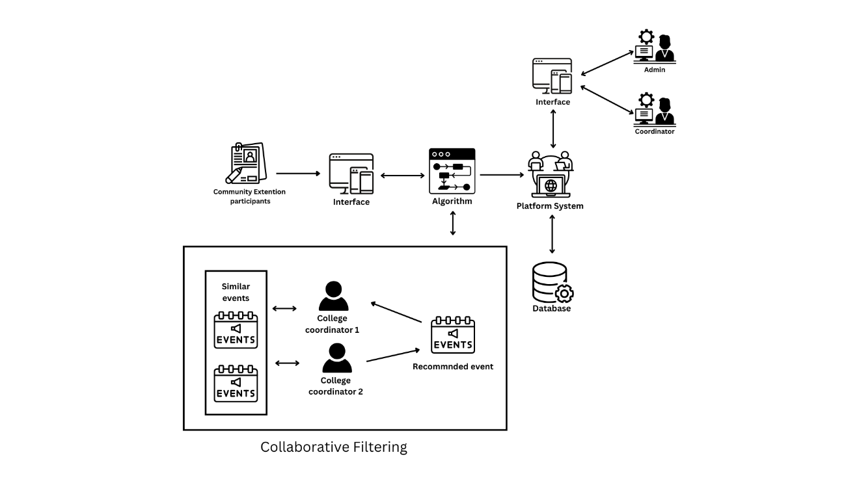

***Figure 2.1 Architectural Framework***

**Figure 2.1** presents the **Architectural Framework** of the "Integrated System for Sustained Community Engagement Enhancing Collaborative Initiatives Across Departments at Pamantasan ng Lungsod ng Pasig" highlighting the intricate relationships between key components. These components include Log In, Overview Dashboard, Project List, Resource Allocation, Task Management, Profile, and Settings. The diagram effectively demonstrates how these elements are interconnected to form a cohesive system that supports the university's collaborative and community engagement efforts.

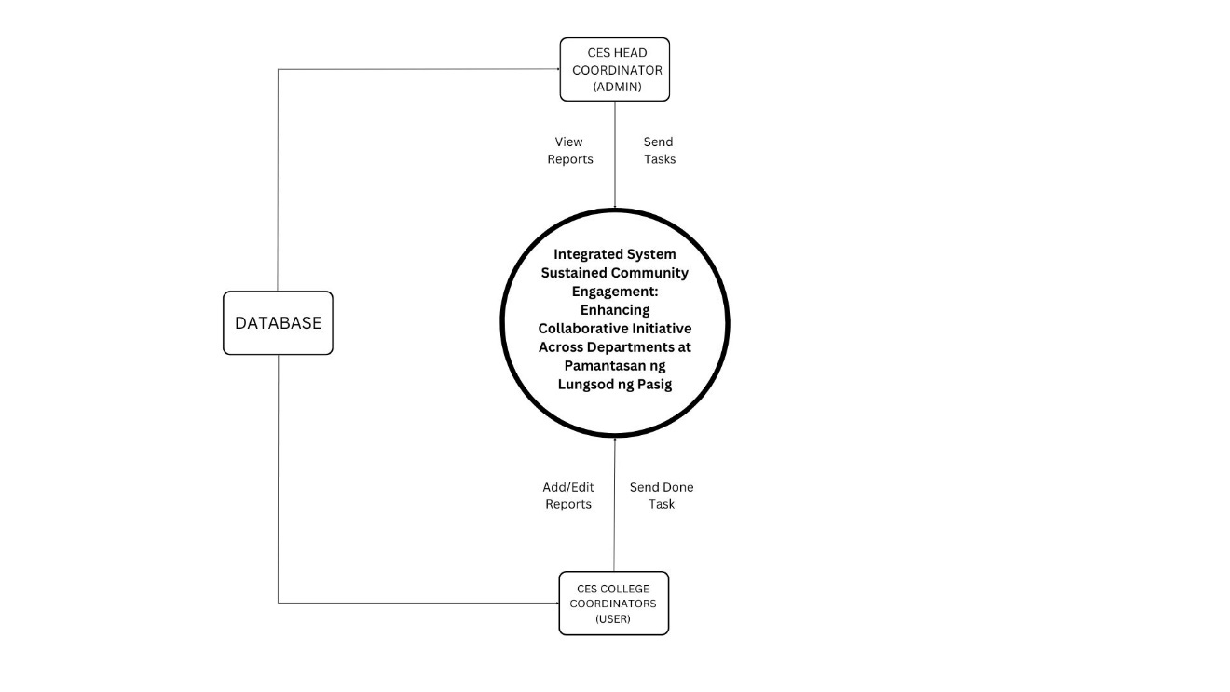 **2.2 Level 0 DFD, or schematic diagram**

***Figure 2.2.1 Level 0 Data Flow Diagram***

In the Level 0 Data Flow Diagram (DFD) that outlines the interactions between two key entities: the CES Head Coordinator, CES College Coordinators. The CES Head Coordinator plays a crucial role by sending and viewing reports submitted by CES College Coordinators. These coordinators are responsible for managing reports through add and edit data as needed. The DFD illustrates the seamless flow of data, where reports are first managed by the CES College Coordinators and then submitted to the CES Head Coordinator for approval and review. Concurrently, Participants engage by submitting forms to become part of the programs, completing the cycle of interaction between these entities.

**2.3 Algorithm Discussion**

Collaborative filtering is an approach that is often used to recommend items or events where, based on a given user’s preferences and the ratings they have given to specific items, some decision is made regarding which items should be recommended. The technique works on the belief that those who have previously rated certain products in a certain manner will likely do the same in the future. Collaborative filtering is a technique in which the content of items does not play a role in determining prominence of items but rather the trends in users and their activities. It typically consists of two types of techniques: user-based, which recommends items to a user that are based on preferences of the target user and the preferences of like users and item-based, which recommends items that are similar to items rated highly by a certain user.

In our case, we apply the collaborative filtering technique that is category-based. Following the completion of an event, participants provide feedback stating whether or not the event achieved its objectives, and such scores are combined to come up with a score for the event in its entirety. In the case of events sponsored by a department, out of the many events only the highest-rated event is selected for recommendation.

The highest-rated events from each department are then recommended to other departments that belong to the same category. This renders it possible to provide such events and activities which are most appropriate to the departments sharing a common academic or thematic focus. Since the recommendation concerns department categories, the system does not offer other dimension events which would be not pertinent to the precise receiving department. This arrangement promotes both collaboration and knowledge exchange across the departments. It ensures that only those departments with similar goals and specialties are involved, making the recommendations efficient and relevant to all departments.

The flow of the logic of collaborative filtering for this study:

**Evaluation of Events Based on their Rated Average**

This computes the average score received by various events across various departments, which excludes the events of the selected departments. It ensures that only the rating that expresses participants’ evaluation towards the given events and not any other factors play a role in the preference of the events. In averaging, it helps to come up with a fair comparison of the events that probably have different rating figures with them.

**Determining the Events with the Highest Ratings**

After the average ratings have been determined, all event ratings by department are averaged, and the highest rated event of each department is selected, provided the rating of that event is above or equal to 4. This system ensures that only the best performing, most rated over the cut-off events are recommended while others that are poorly rated are left out so as to maintain quality.

𝑀 = maximum rated event

**Filtering by Similar Categories**

Events organized by departments are basically of the same theme or interest which is known as the event category. By analyzing the categories of events in the selected department against those of other departments, the system is able to detect departments with similar interests. For this reason, this stage ensures that the user events recommended are appropriate with regards to the user department by looking at the events from the departments that have similar categories.  
  
For the selected department (𝑆), identify all departments (𝐷′) that share at least one common category in their event lists:

Where the set intersection is indicated by ∩.

**Filtering the Recommended Events**

After the events rated the highest are detected and the departments that are compatible similar are established, the next step is to narrow down the events to include only the ones that are from departments that profile similar to the selected department by sharing categories. This guarantees that the suggestions provided are of high quality and also appropriate to the area of concern for the user.

𝐸 (an event) is included in the set 𝑀 (maximum-rated events) if the department 𝐷 (where the event belongs) is in the set of Similar Departments.

After these processes, Events that have been filtered will be displayed in a simple and straightforward list, only featuring the top-rated events of departments that have common interest. This last step enables the user to efficiently search for events that suit their preferences and are of high quality, thus enhancing the quality of the experience of the user overall.

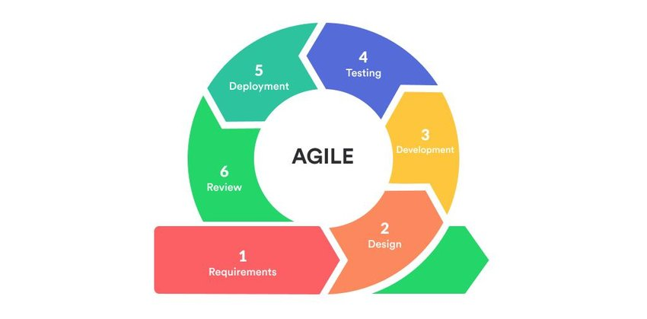 **2.4 Software Engineering Paradigm**

**Figure 2.4.1 Agile Model**

In Figure 2.4.1 illustrates Agile Mode, it is employed for its organized approach, integrating testing throughout the entire software development process. It is a matter of creating a variable, cyclic event to plan, test and introduce the system efficiently. It comprises the following elements for structured approach using Agile methodology.

**Plan**

The researchers analyzed and identified the current situation and problems that are experiencing by the client in processing of data. The requirement phase involves gathering detailed inputs from faculty, administrative staff, and community partners. This phase focuses on identifying specific needs such as real-time communication tools, project management features, and data reporting functionalities. It also includes defining the system's objectives, such as improving inter-departmental coordination and tracking community engagement activities. Comprehensive documentation is created to outline these requirements, ensuring alignment with the institution’s strategic goals.

**Design**

During the design phase, the architecture of the system is outlined based on the requirements gathered. This includes creating detailed wireframes and mockups that represent the user interface and experience. The design focuses on integrating modules that facilitate communication, project tracking, and data analysis. It also involves database design to ensure efficient data storage and retrieval. The design is reviewed iteratively with the client to ensure it meets their needs and expectations before moving to development.

**Develop**

The development phase involves translating the design into a functional system. This includes coding the various modules, integrating them into a cohesive application, and ensuring that all features align with the design specifications. Developers implement user interfaces, database connections, and backend functionalities. Regular meetings with the client are held to provide updates and gather feedback. Any issues or changes identified during this phase are addressed promptly to maintain alignment with the initial requirements.

**Test**

In the testing phase, the integrated system undergoes rigorous evaluation to identify and resolve any issues. This includes functional testing to ensure all features work as intended, performance testing to assess the system’s stability under load. Feedback from testing is used to make necessary adjustments and improvements before finalizing the system.

**Deploy**

The final deployment procedure begins once the software testing step is completed, and no bugs or errors are remaining in the system. The finished software is released and tested for deployment issues based on the client’s feedback.

**Review**

The review phase involves evaluating the project’s success against the initial requirements and objectives. Feedback is gathered from users to assess system performance and identify areas for improvement. A recap review is held at this phase to talk about what went well, what may be improved, and how the lessons learned can be applied to future projects. The review process informs upcoming system enhancements and aids in ongoing improvement.

**2.5 Mock-Ups**

**Head Coordinator / College Coordinator**

This splash page serves as the introductory screen for the Integrated System for Sustained Community Engagement. Featuring a prominent tagline, it sets the tone and purpose of the platform, welcoming users and guiding them towards logging in, creating an account through the **Account Button**, or exploring further. This initial interface is designed to capture attention and provide a clear entry point into the system.

***Figure 2.5.1 Splash Page***

**Head Coordinator / College Coordinator**

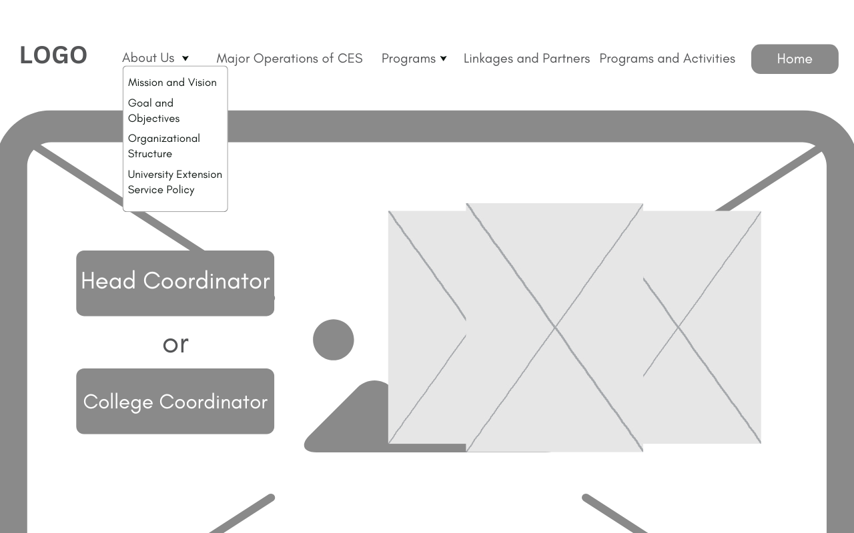 The dropdown menu under the "About Us" section is a key component of the navigation bar. It provides a list of sub-items that appear when the main "About Us" button is clicked. Each sub-item, such as Mission and Vision, Goal and Objectives, Organizational Structure and University Extension Service Policy. It represents a variable that directs the user to specific information pages.

***Figure 2.5.2 About Us***

**Head Coordinator / College Coordinator**

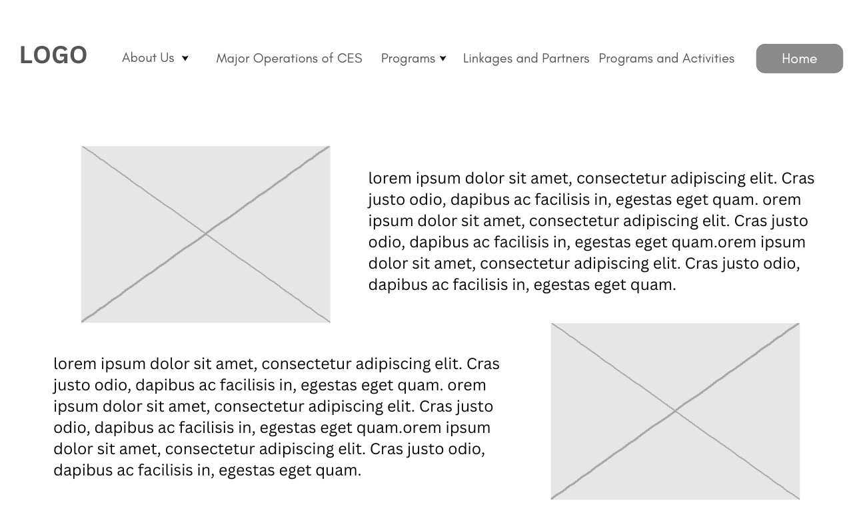  
 The “Mission and Vision” page provides a clear overview of our organization’s core purpose and long-term goals. It outlines our mission, which details what we aim to achieve, and our vision, which describes the strategic direction we are pursuing. This section helps users understand the foundational aims of the Community Extension and the future aspirations guiding our efforts.  
 ***Figure 2.5.3 Mission and Vision***

**Head Coordinator / College Coordinator**

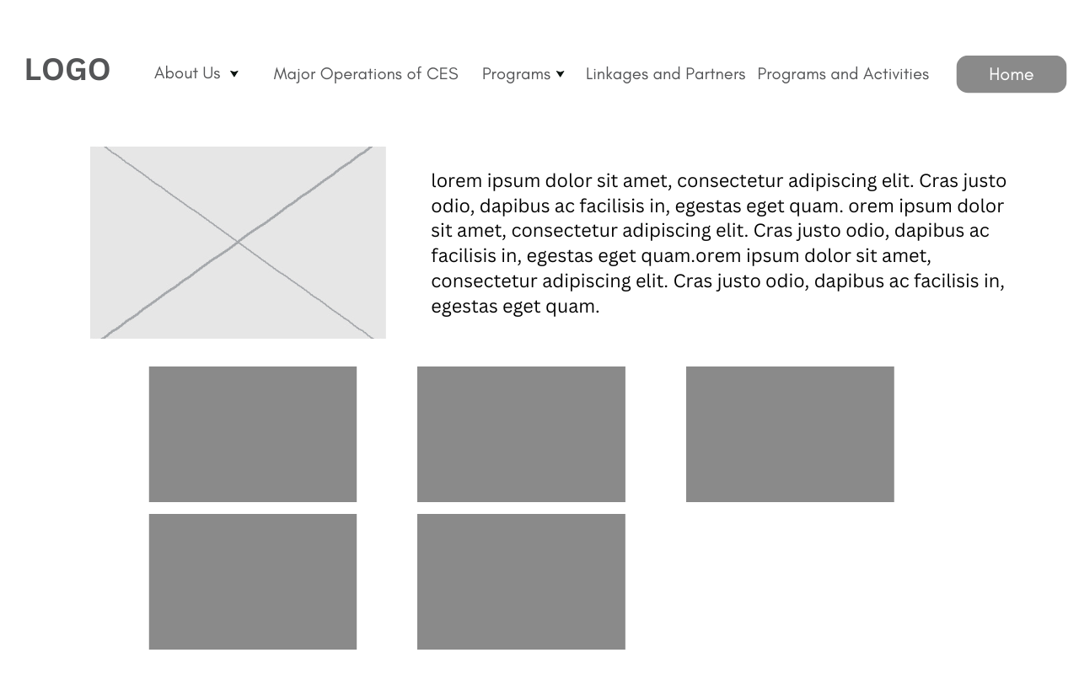  
 The “Goals and Objectives” page delivers an in-depth look at our organization’s strategic targets and plans. It outlines the specific goals we are working towards and the objectives that will guide our progress. This section provides users with insight into the operational milestones of the Community Extension and the actionable steps we are taking to realize our long-term vision.  
  
 ***Figure 2.5.4 Goals and Objectives***

**Head Coordinator / College Coordinator**

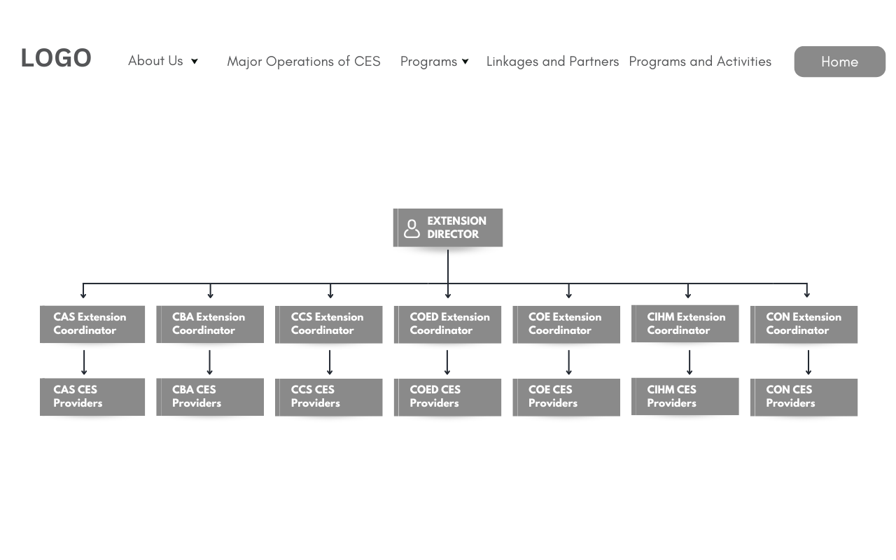  
 The “Organizational Structure” page offers an in-depth look at the individuals engaged in community services, highlighting the hierarchy, roles, and various departments. It provides a clear picture of how the team is organized and the different functions within the organization.

***Figure 2.5.5 Organizational Structure***

**Head Coordinator / College Coordinator**

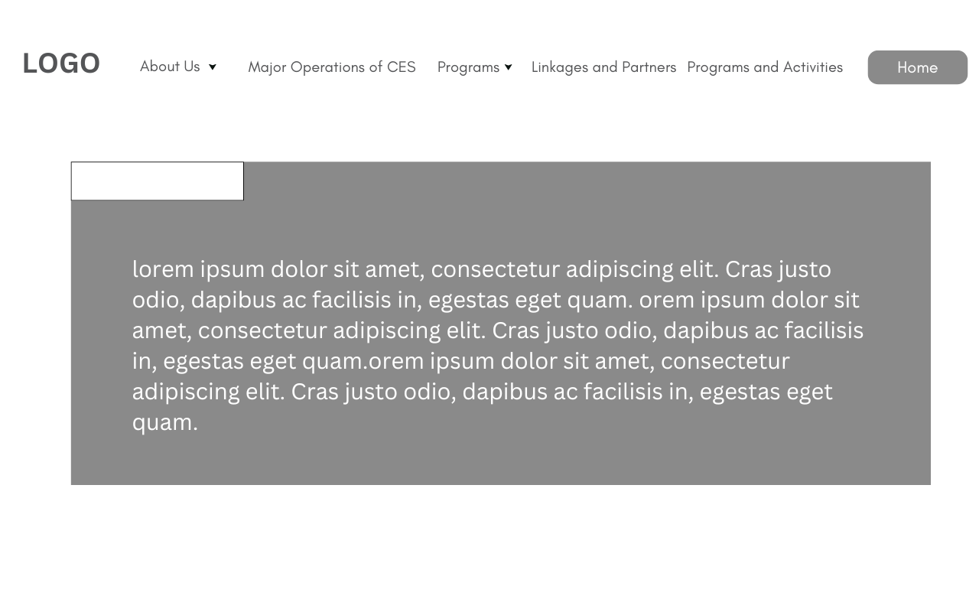  
 The "University Extension Service Policy" page provides a comprehensive overview of the laws and policies that govern our extension services, including compliance requirements, guidelines for service delivery, and standards to ensure effectiveness and integrity.

***Figure 2.5.6 University Extension Service Policy***

**Head Coordinator / College Coordinator**

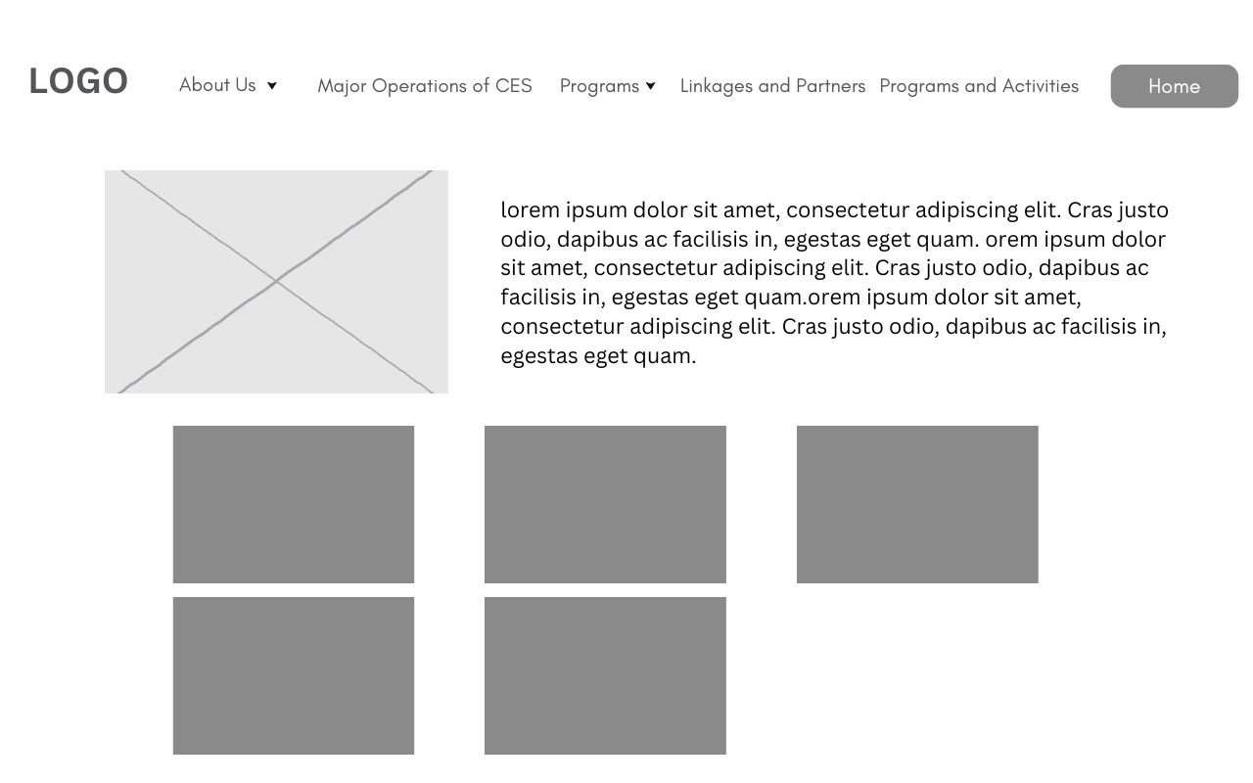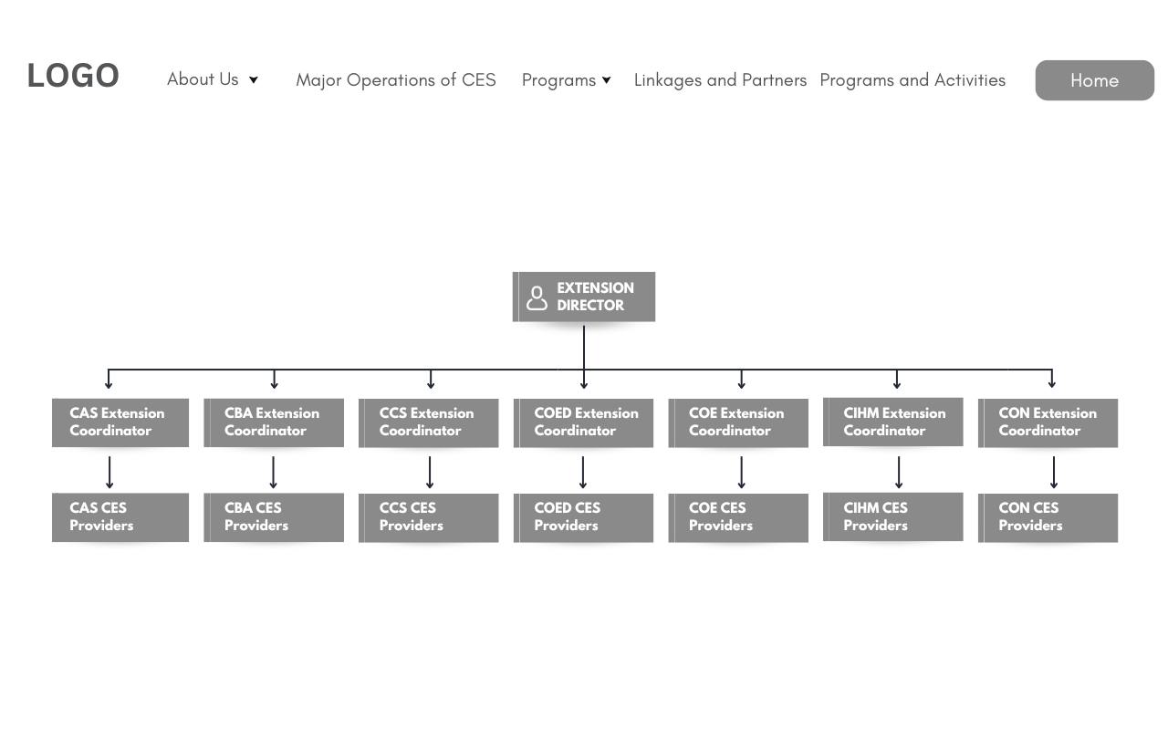

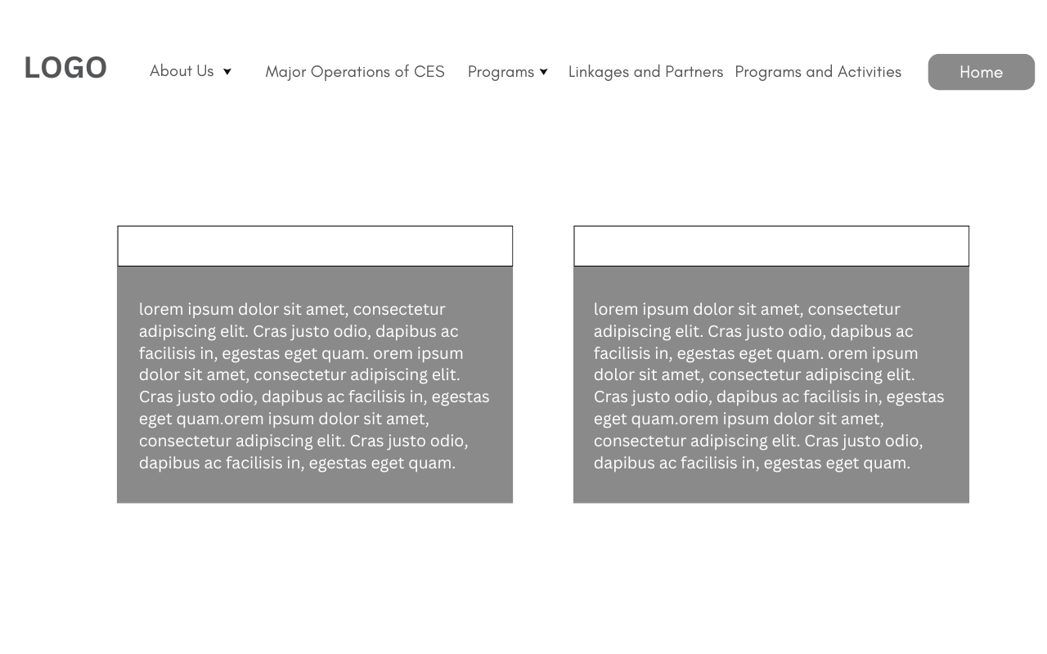The "Major Operation of CES" button on the navigation bar provides detailed information about our two key operations: the Community Engagement Program and the Community Extension Program.

***Figure 2.5.7 Major Operations of CES***

**Head Coordinator / College Coordinator**

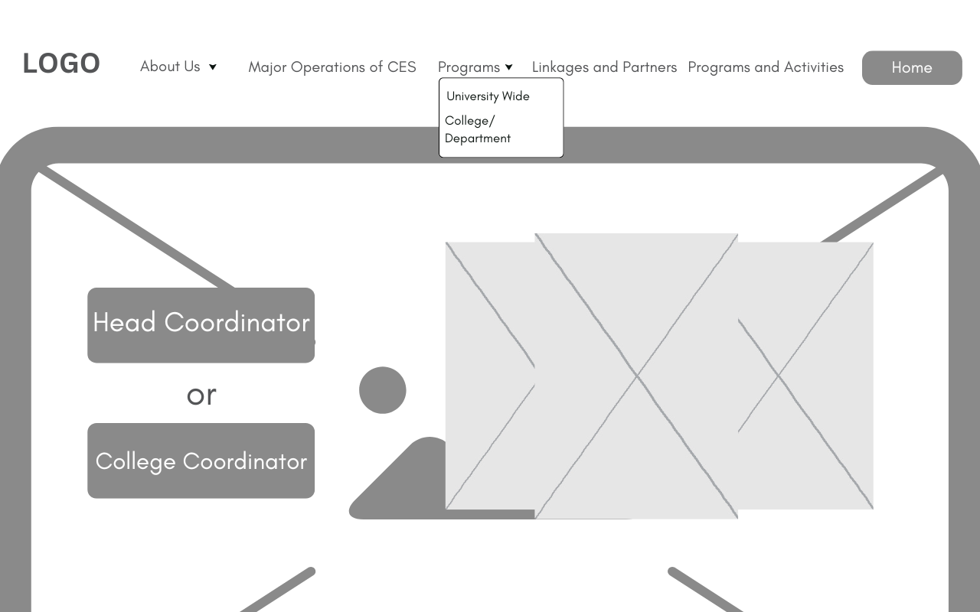  
 The "Programs" page features a dropdown menu that includes sections for both University-wide initiatives and College/Department programs. The University-wide initiatives section highlights major programs and projects that involve the entire institution, while the College/Department programs section details specific programs associated with each college or department.  
 ***Figure 2.5.8 Programs***

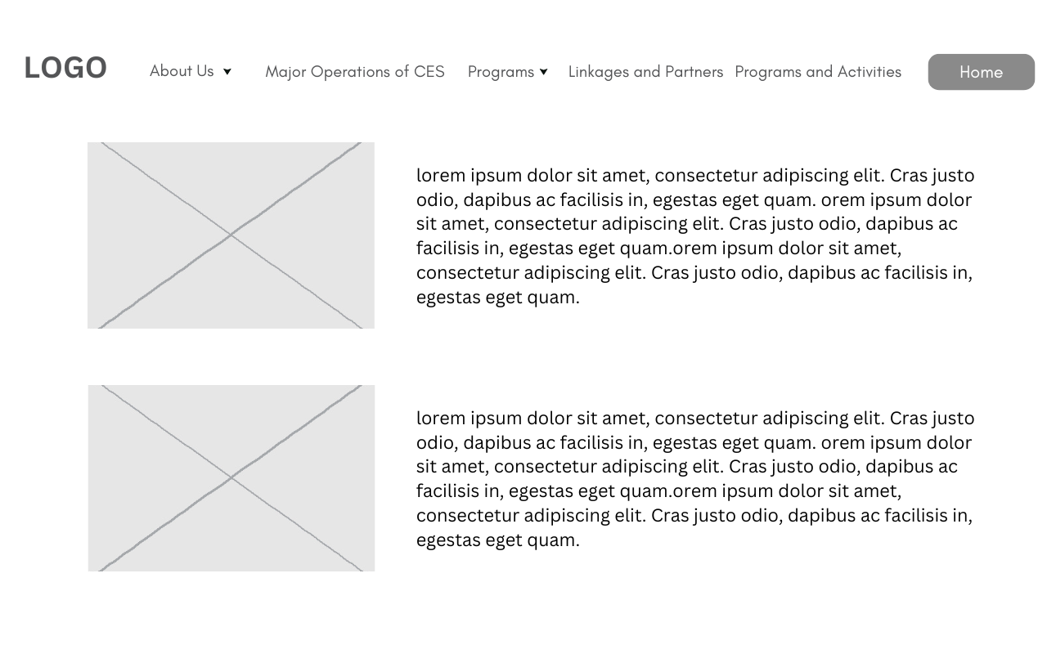**Head Coordinator / College Coordinator**  
 The "University-Wide Programs" page offers comprehensive information about our institution-wide initiatives, detailing diverse programs and activities that engage all facets of the university community.  
  
 ***Figure 2.5.9 University Wide***

**Head Coordinator / College Coordinator** The "College/Department Programs" page provides comprehensive information on the unique programs assigned to each of the seven colleges. It outlines the specific initiatives, activities, and projects that each college is responsible for, highlighting their objectives and impact.

***Figure 2.5.10 College/Department Programs***

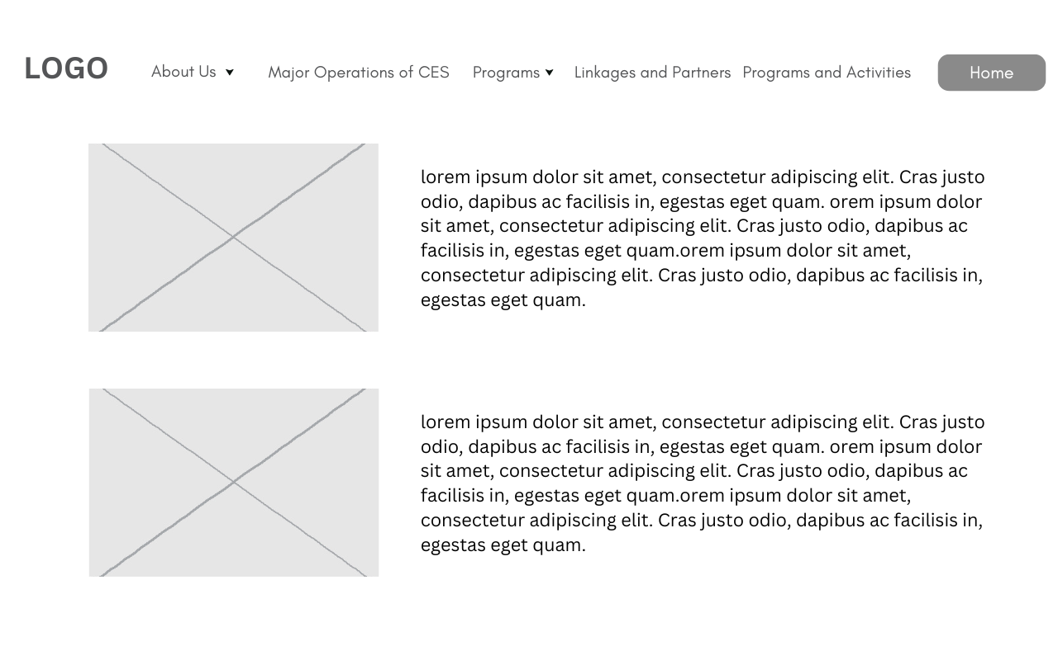

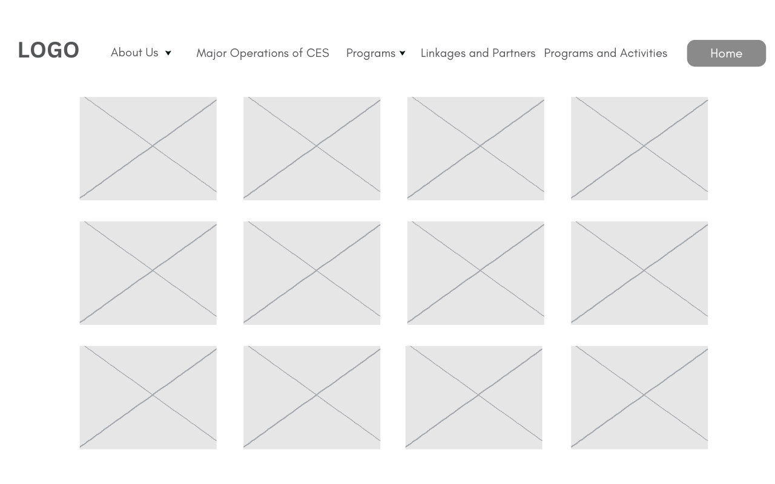**Head Coordinator / College Coordinator** The "Linkages and Partners" page showcases all the sponsors and partners of our community programs, highlighting the collaborative relationships that support and enhance our initiatives. ***Figure 2.5.11 Linkages and Partners***

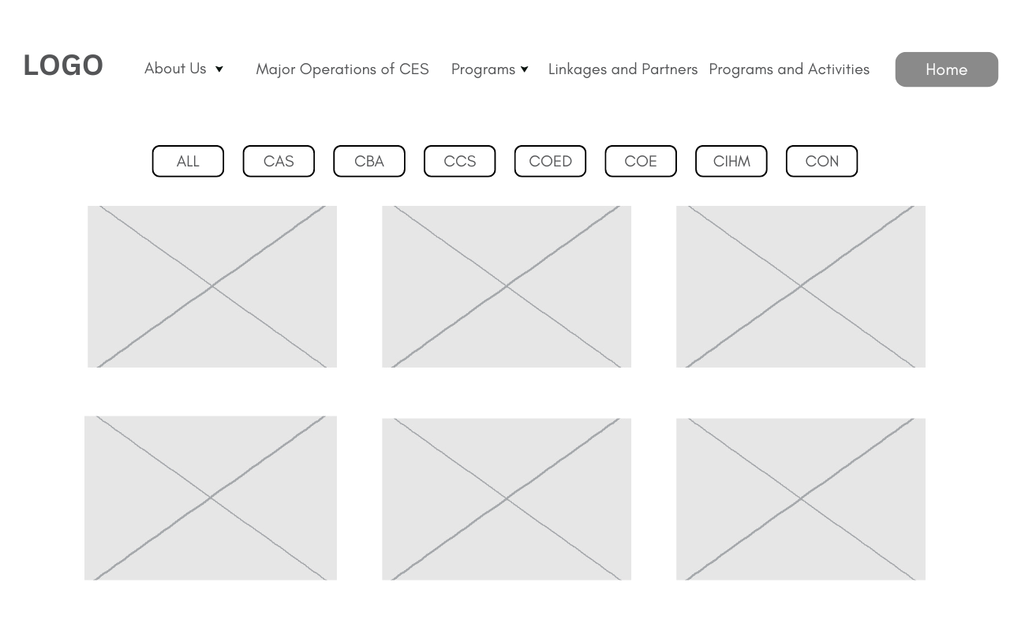**Head Coordinator / College Coordinator** The "Programs and Activities" page features an extensive collection of photographs documenting the wide range of programs and activities we have undertaken.

***Figure 2.5.12 Programs and Activities***

**Head Coordinator / College Coordinator** This “Role Account” page allows users to choose their role as either the Head Coordinator end or College Coordinator before entering the system. Both the Head Coordinator and the College Coordinator have assigned keys.

***Figure 2.5.13 Programs and Activities***

**Head Coordinator / College Coordinator**

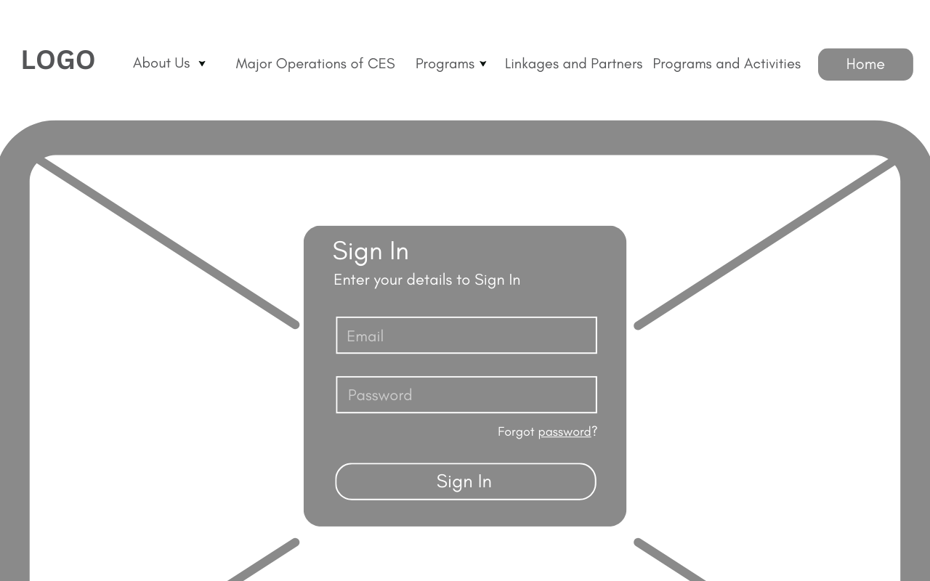 The "Sign In" page has fields for email and password input. Users must enter their credentials before accessing the dashboard.  
  
 ***Figure 2.5.14 Sign in Page***

**Head Coordinator / College Coordinator**

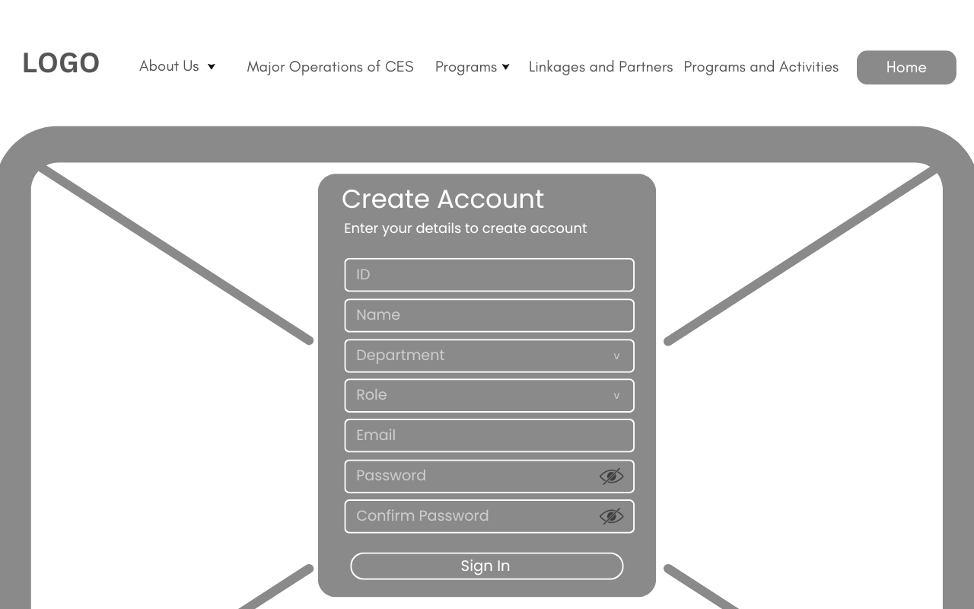 The "Create Account" page includes fields for ID, Name, Department, Role, Email, Password, and Confirm Password, requiring users to complete all fields to register and gain access to the system.

***Figure 2.5.15 Create Account Page***

**Head Coordinator / College Coordinator**

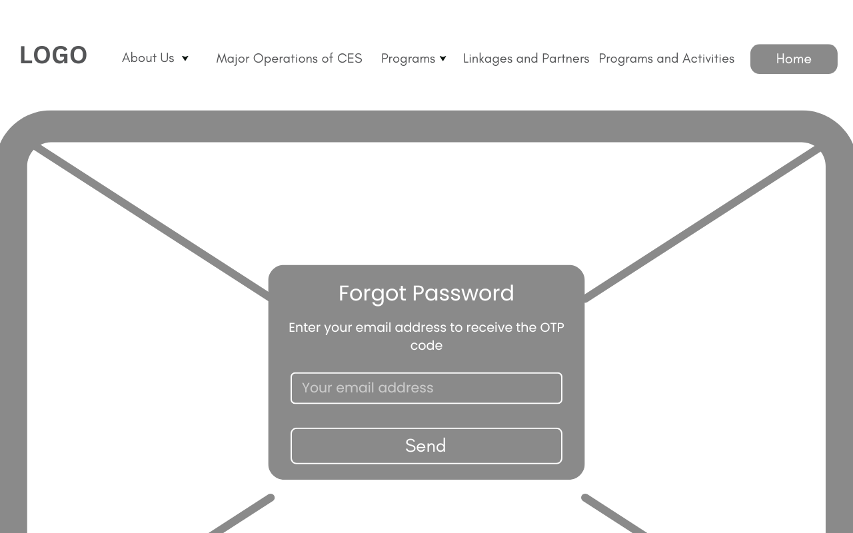 The "Forgot Password" page allows users to reset their password by entering their email address and clicking the **Send** button to receive a one-time password (OTP) for verification.

***Figure 2.5.16 Forgot Password Page***

**Head Coordinator / College Coordinator**

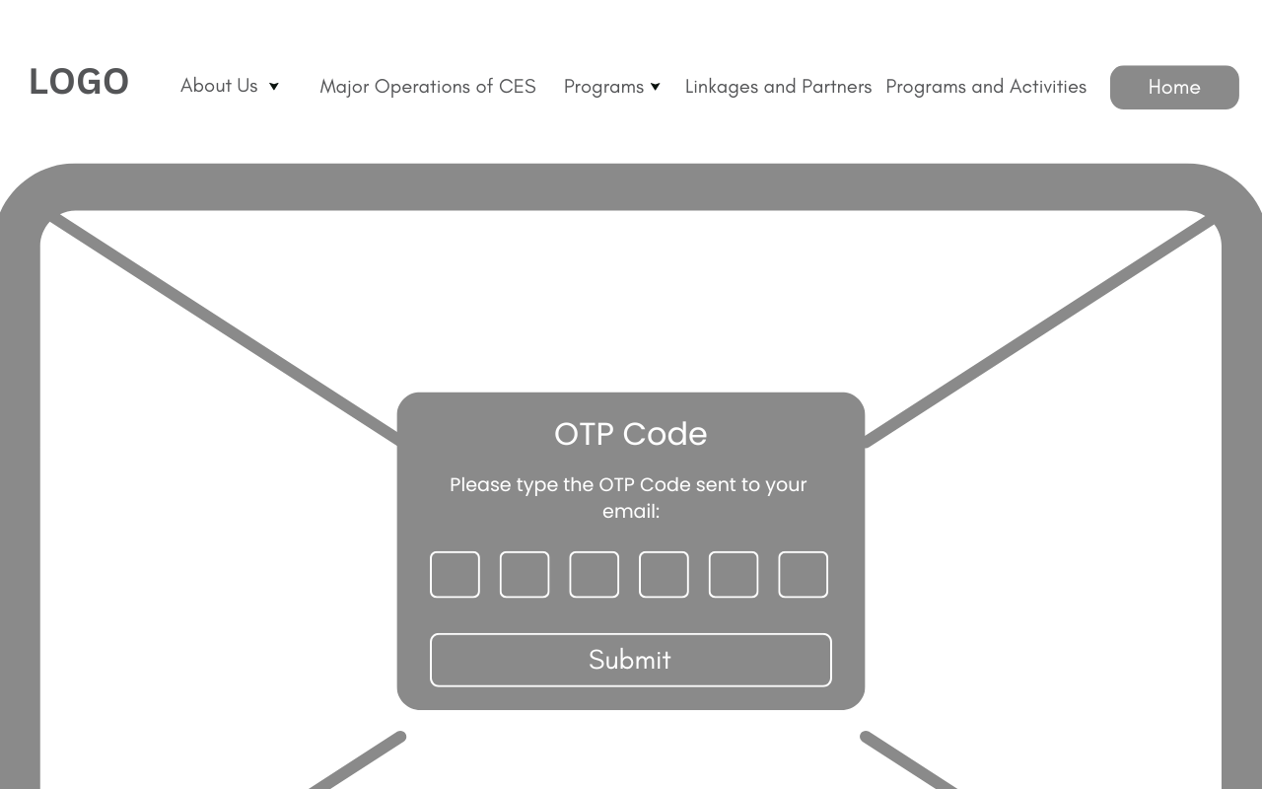 The "OTP Verification" page prompts users to enter the 6-digit code sent to their registered email address to verify their identity and proceed with resetting their password.

***Figure 2.5.17 OTP Page***

**Head Coordinator / College Coordinator**

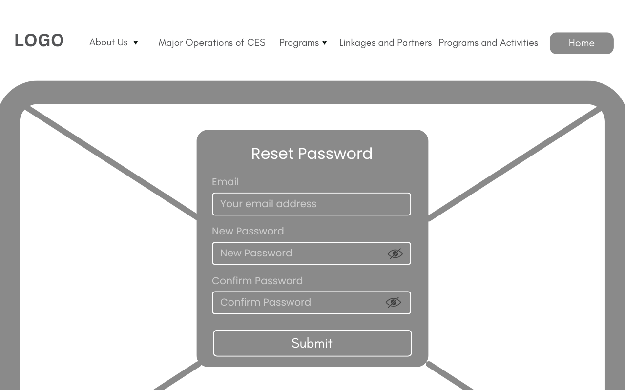 The "Reset Password" page requires users to enter their registered email address, a new password, and confirm the new password to successfully reset their account credentials.

***Figure 2.5.18 Reset Password Page***

**Head Coordinator / College Coordinator**

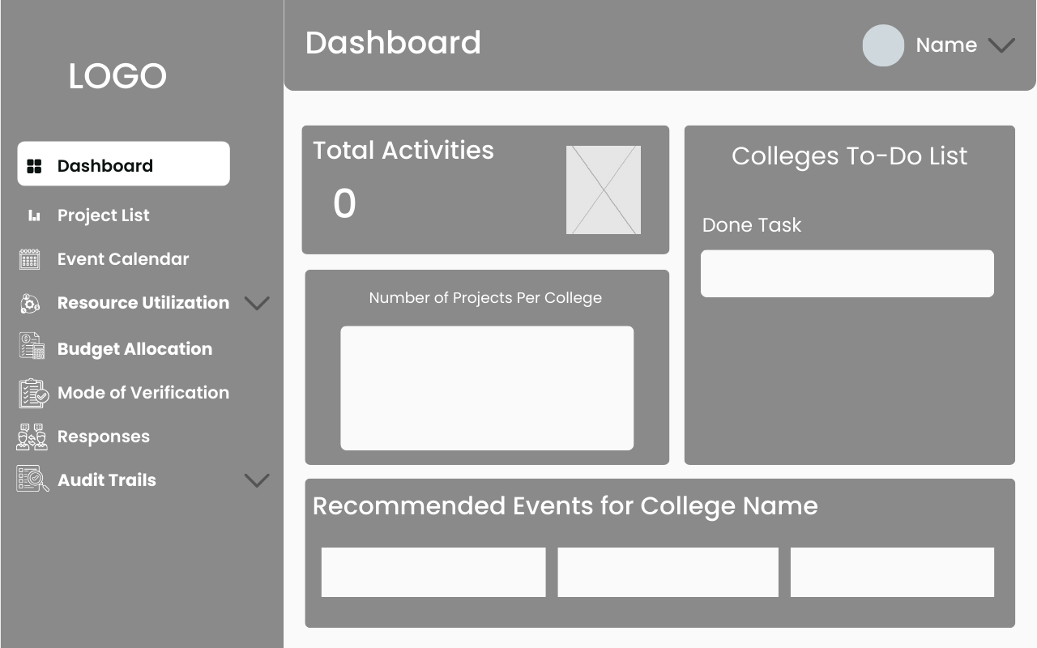 The Dashboard page provides an overview of the system, displaying the total activities, a to-do list for colleges and admin, a bar graph illustrating the number of projects per college, and a section for recommended events tailored to each college.

***Figure 2.5.19 Colleges Dashboard Page***

***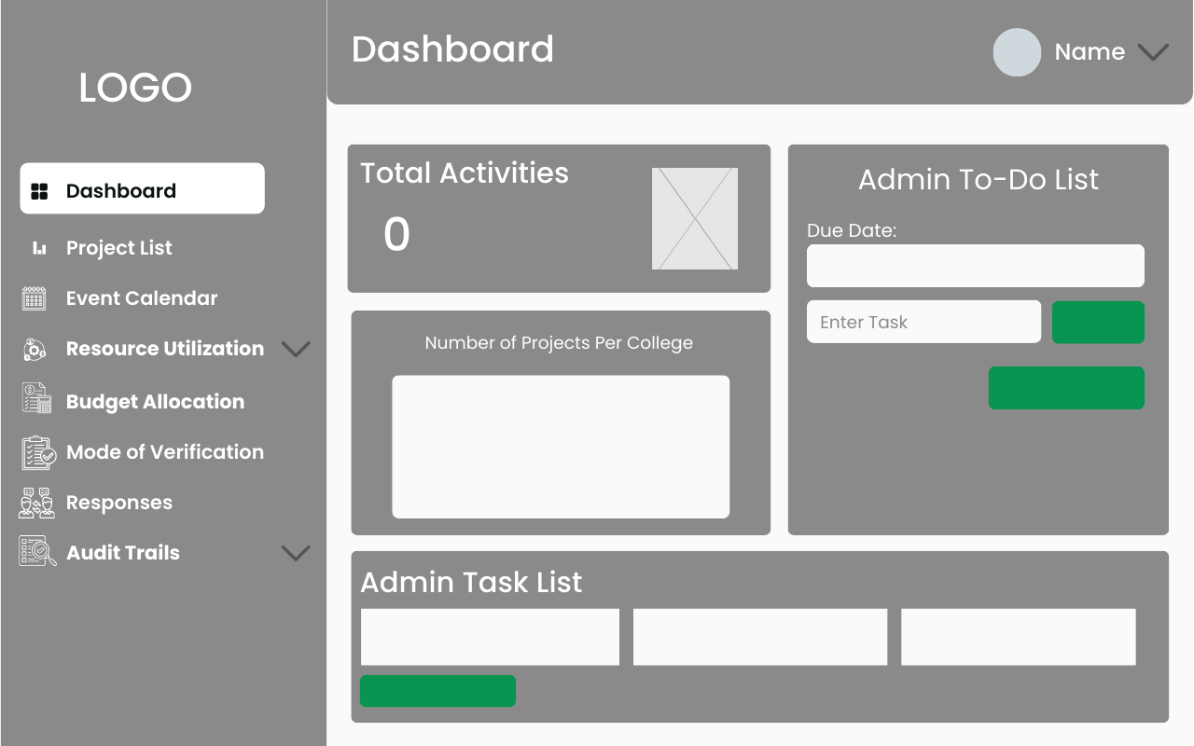  
  
Figure 2.5.20 Head Dashboard Page***

**Head Coordinator / College Coordinator**

******The “Project List” page allows users to add and edit their projects while providing administrators with a comprehensive view of all projects submitted by the colleges.

***Figure 2.5.21 Colleges Project List Page***

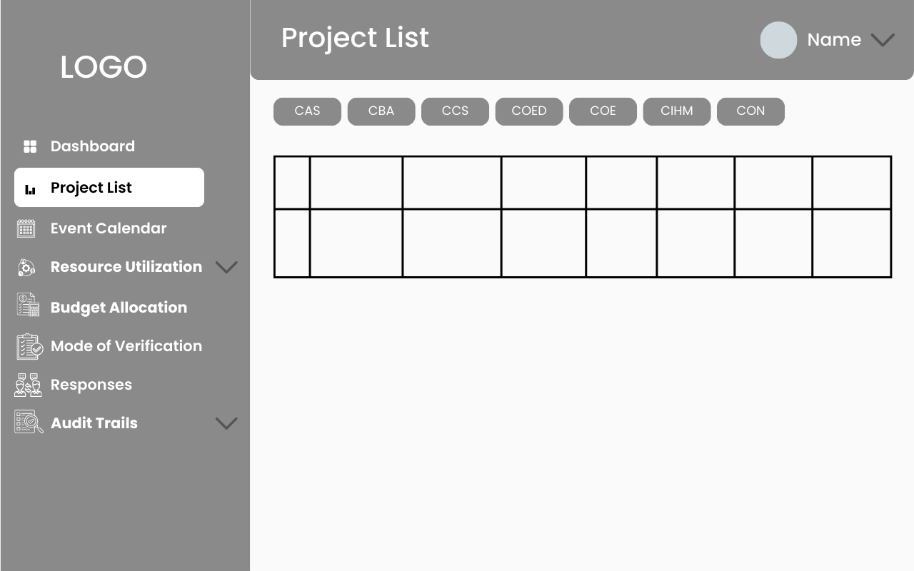

***Figure 2.5.22 Head Project List Page***

**Head Coordinator / College Coordinator**

The “Event Calendar” page allows colleges to view their own calendar events, while administrators can access and see events from all colleges in a unified calendar.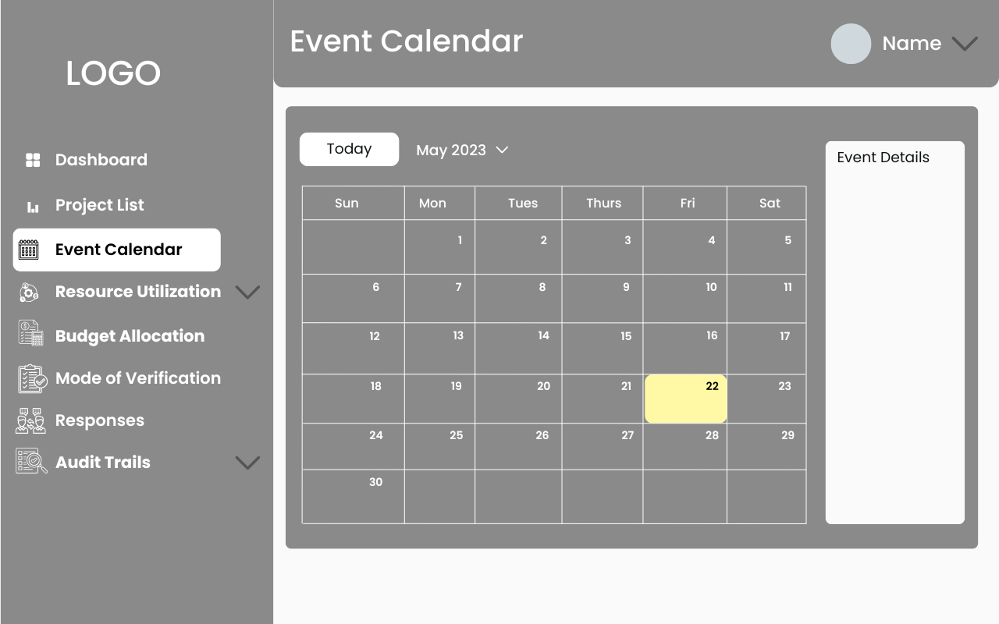

***Figure 2.5.23 Colleges Event Calendar Page***

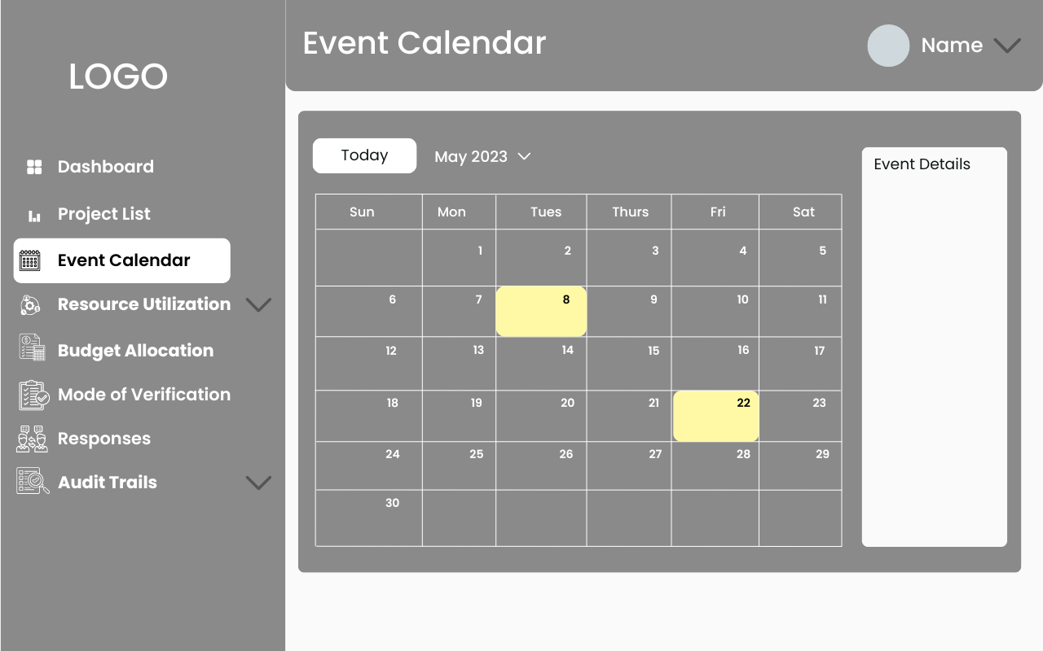

***Figure 2.5.24 Head Event Calendar Page***

**Head Coordinator / College Coordinator**

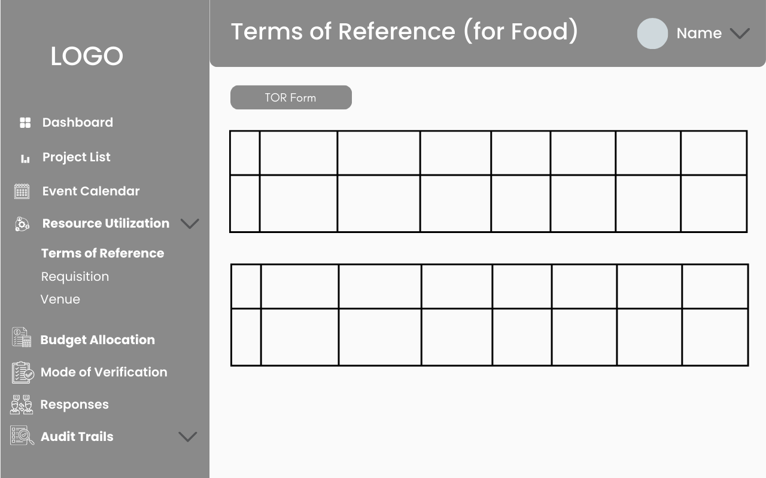 The Resource Utilization page, focused on the “Terms of Reference”, allows colleges to submit information regarding their food requests, while the Head Coordinator can view all submissions from their side.

***Figure 2.5.25 Colleges Term of Reference Page***

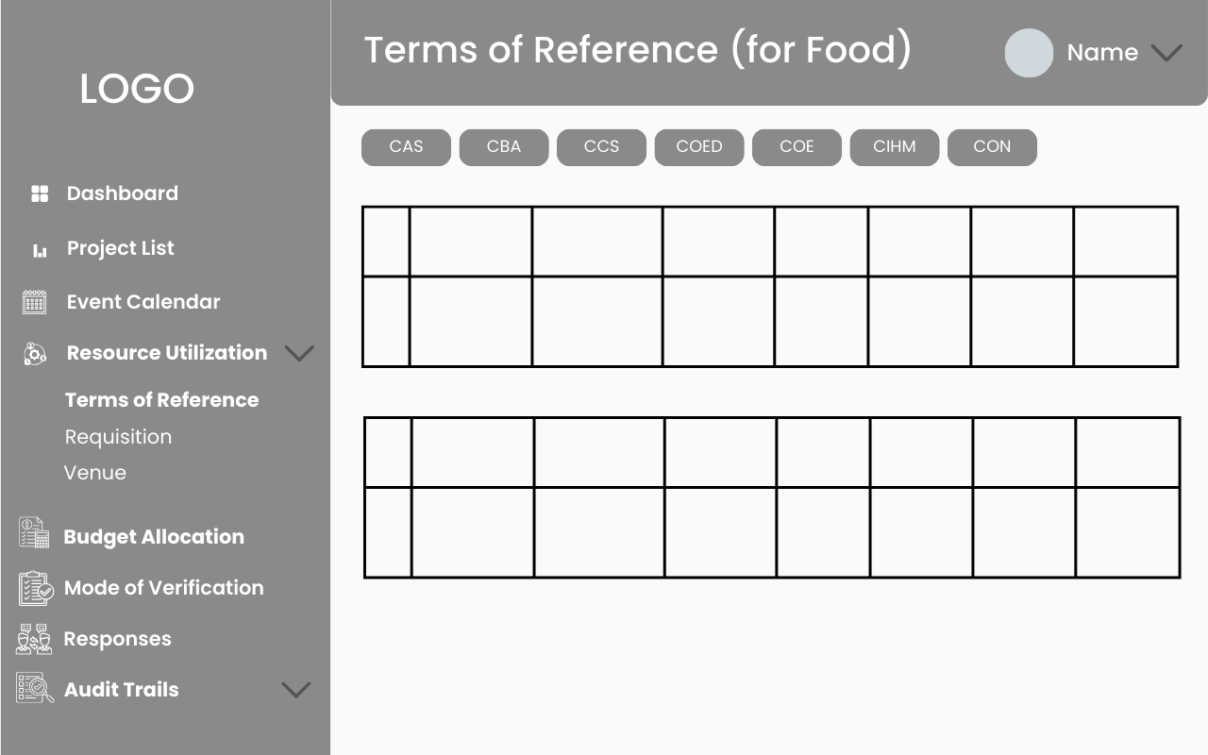

***Figure 2.5.26 Head Term of Reference Page***

**Head Coordinator / College Coordinator**

The Resource Utilization page, focused on “Requisitions”, allows colleges to submit information regarding their materials requests, while the Head Coordinator can view all submissions from their side.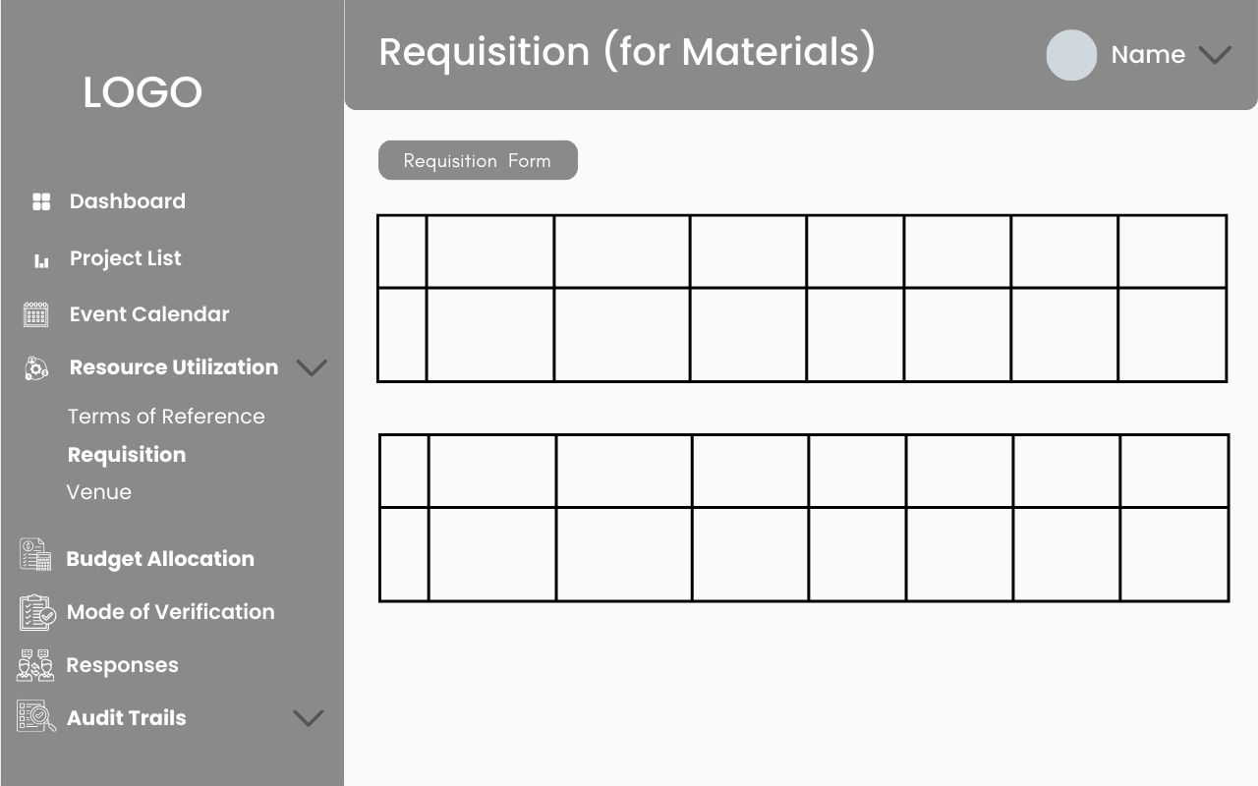

***Figure 2.5.27 Colleges Requisition Page***

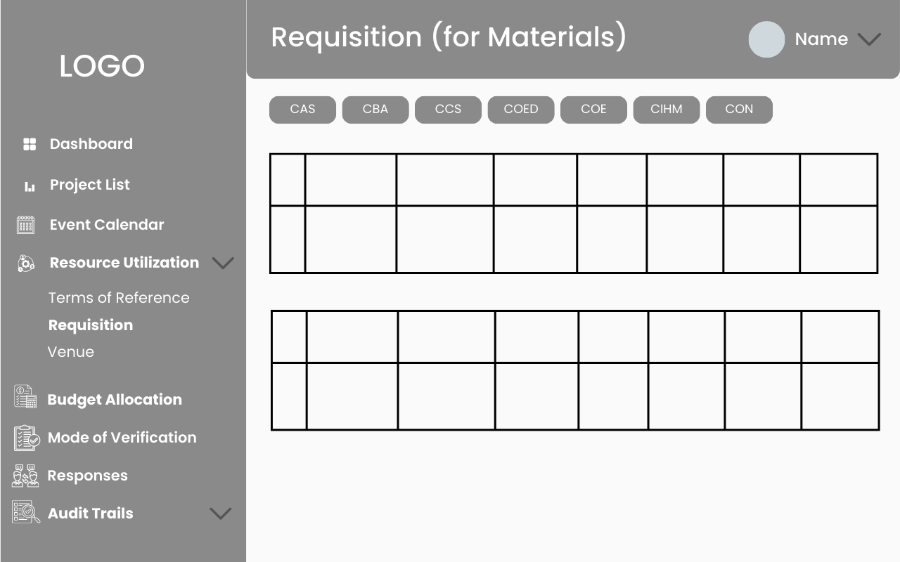

***Figure 2.5.28 Head Requisition Page***

**Head Coordinator / College Coordinator**

The “Venue” page allows colleges to submit information regarding their venue requests, while the Head Coordinator can view all submissions from their side. 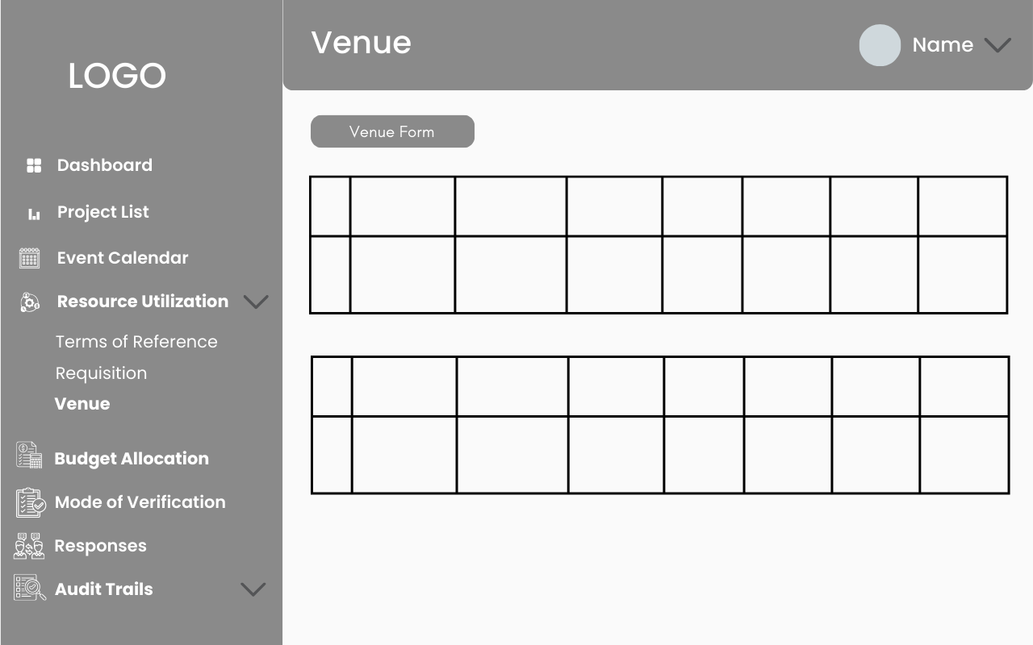

***Figure 2.5.29 Colleges Venue Page***

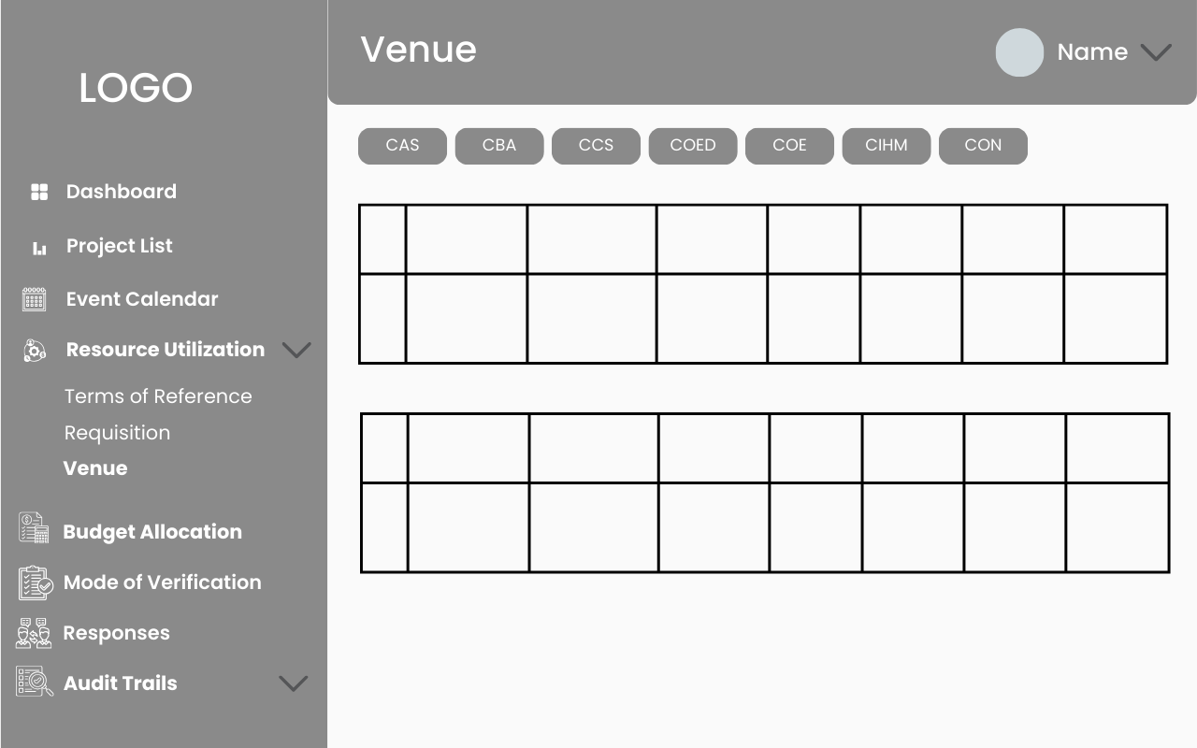

***Figure 2.5.30 Head Venue Page***

**Head Coordinator / College Coordinator**

The “Budget Allocation” page allows the admin to set the budget for all colleges, while colleges can add projects and expenses related to those projects. They can also view the remaining balance available for each project, helping manage funds effectively. 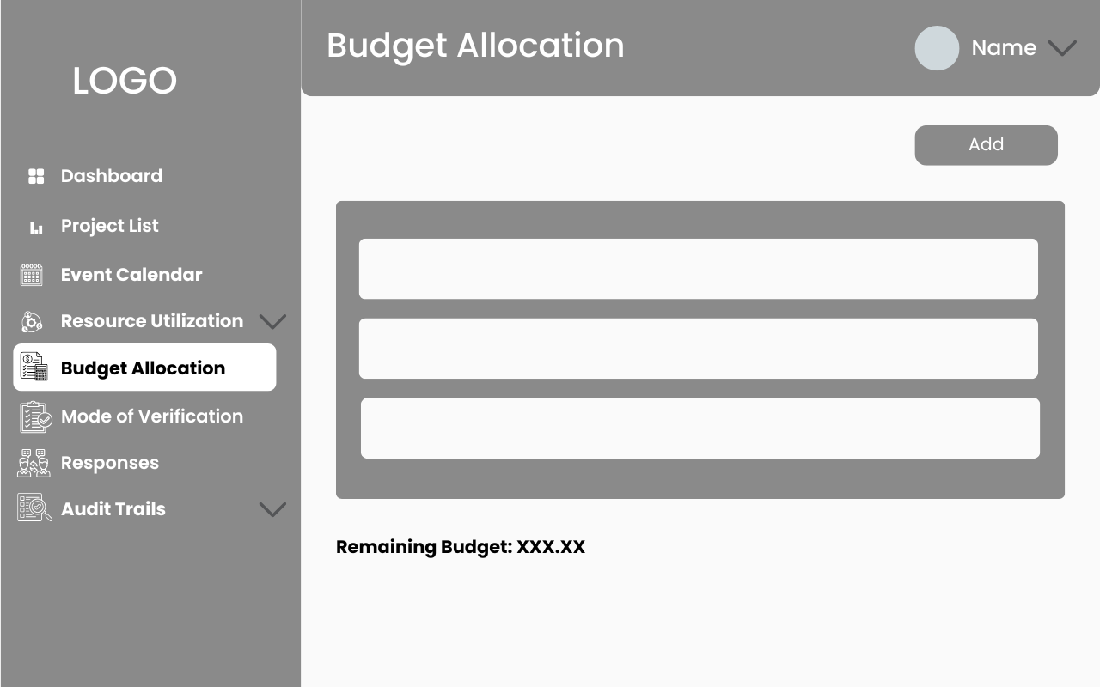

***Figure 2.5.31 Colleges Budget Allocation Page***

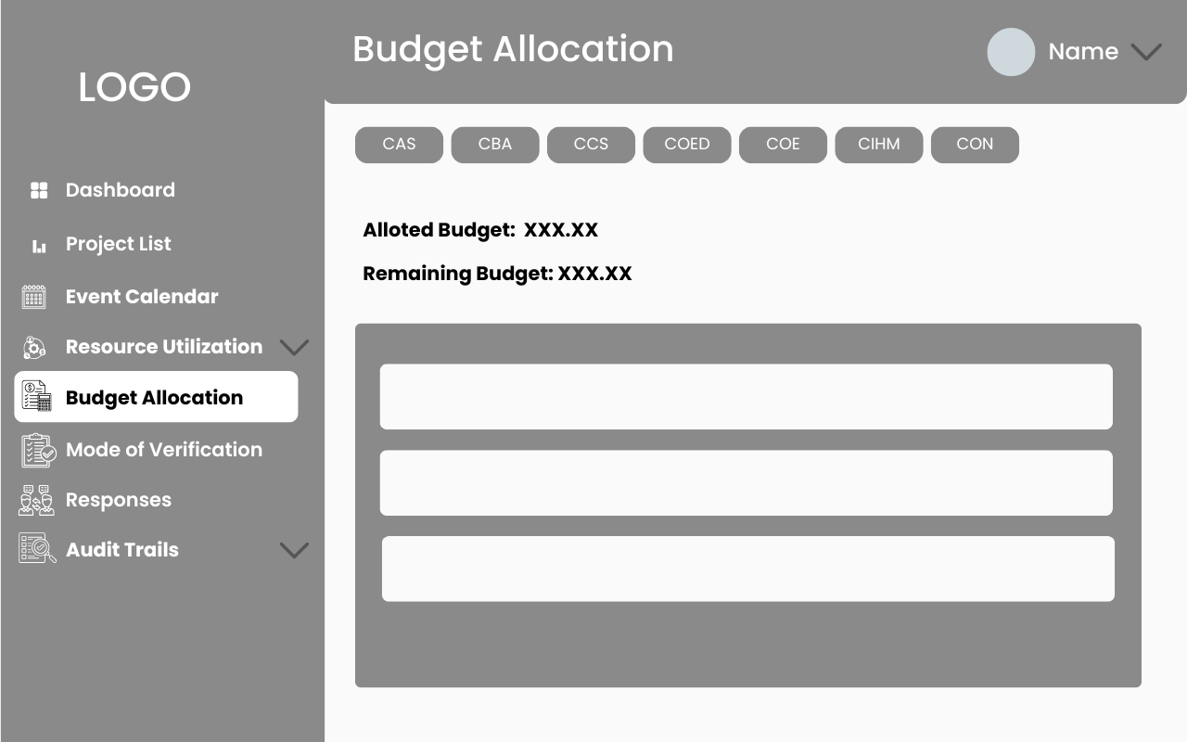

***Figure 2.5.32 Head Budget Allocation Page***

**Head Coordinator / College Coordinator**

The Mode of Verification page ensures that when colleges submit a new event, it automatically creates a new folder and subfolders to organize the event’s files. The Head Coordinator can view all submitted files and images from the colleges, providing an efficient way to manage event documentation. 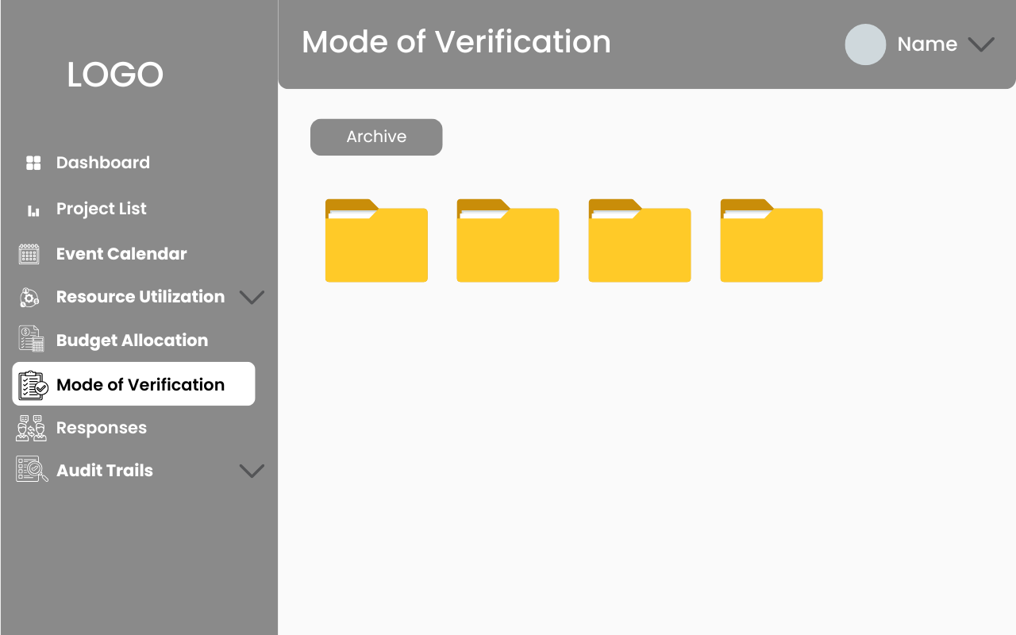

***Figure 2.5.33 Colleges MOV Page***

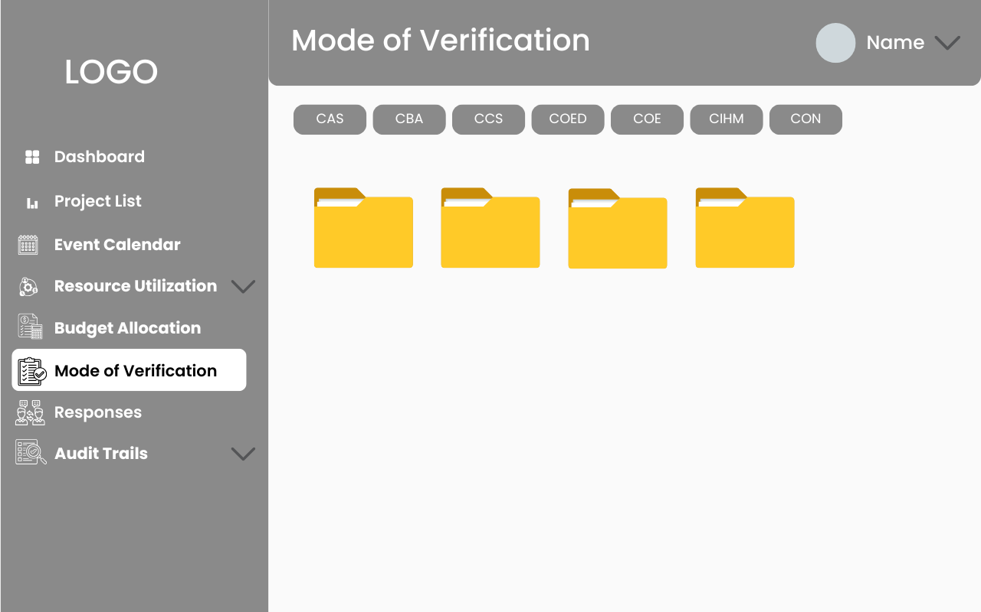

***Figure 2.5.34 Head MOV Page***

**Head Coordinator / College Coordinator**

The Responses page allows each college to view all evaluation forms submitted by participants and provides the ability to send certificates to participants, ensuring efficient management of feedback and recognition.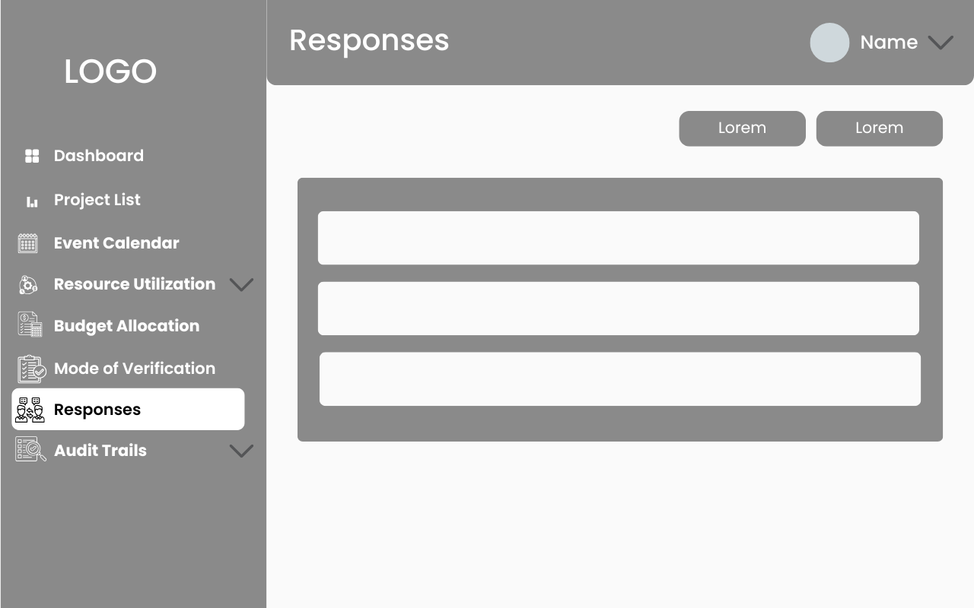

***Figure 2.5.35 Head / Colleges Responses Page***

**Head Coordinator / College Coordinator**

The “Login History” page allows both the Head Coordinator and colleges to view their login and logout times, providing a clear record of system access and activity. 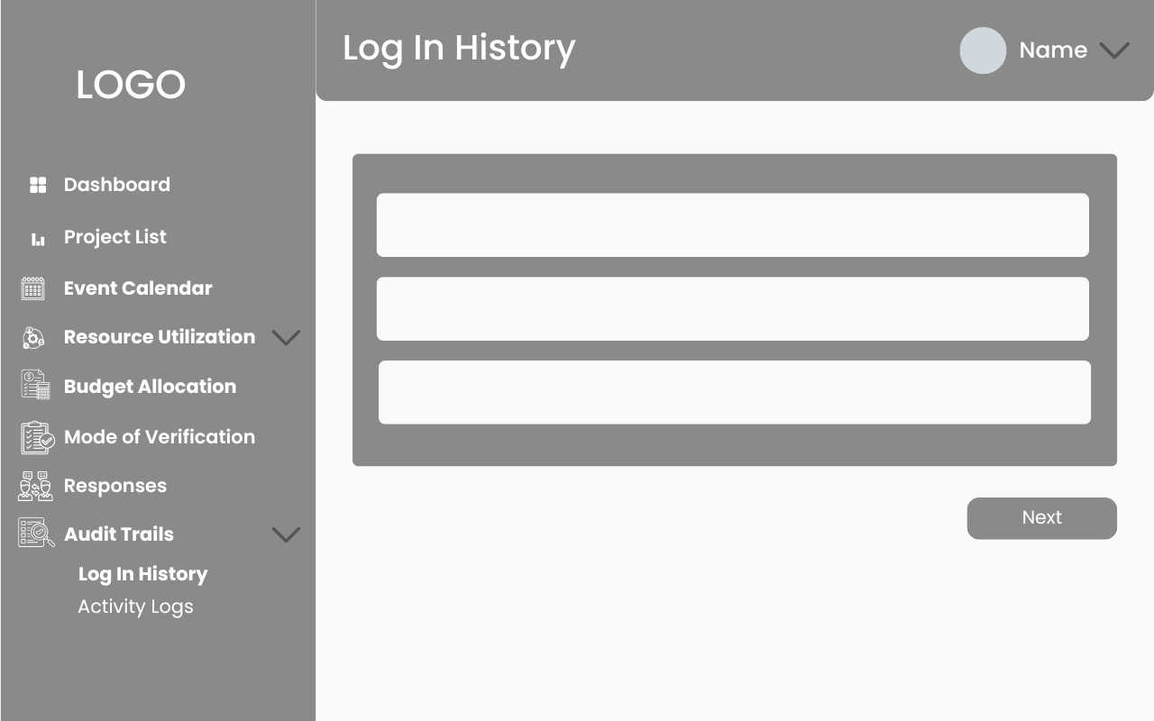

***Figure 2.5.36 Colleges / Head Log In History Page***

**Head Coordinator / College Coordinator**

The “Activity Logs” page allows both colleges and the Head Coordinator to see a detailed record of all actions performed, including clicks and activities within the system, ensuring transparency and tracking of user interactions.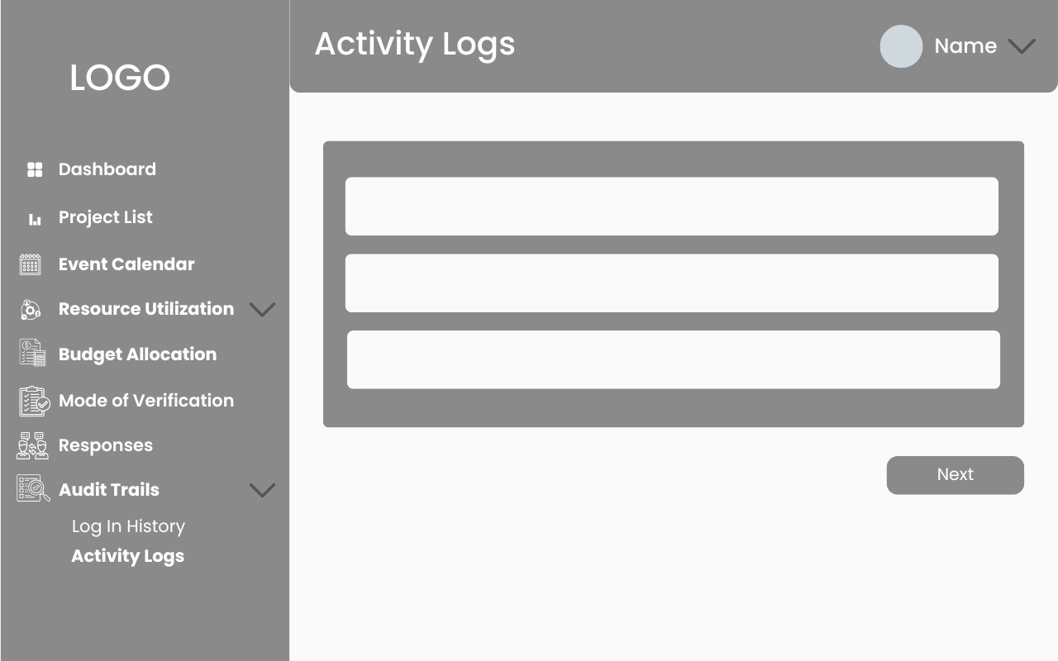

***Figure 2.5.37 Colleges / Head Activity Logs Page***

**Head Coordinator / College Coordinator**

The “Profile” page allows both the Head Coordinator and colleges to view their profile picture, personal details, and account information, providing a centralized space to manage and review their profile.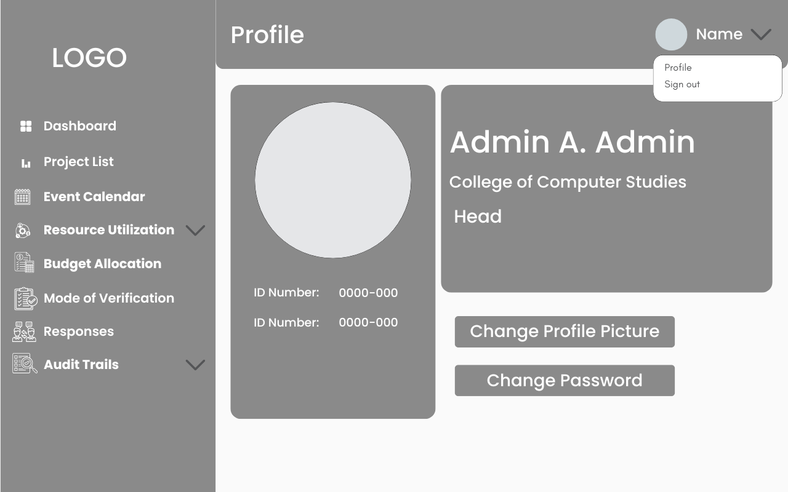

***Figure 2.5.38 Colleges / Head Profile Page***

**Head Coordinator / College Coordinator**

The “Edit Profile” page allows both the Head Coordinator and colleges to update their profile picture, ensuring their profile remains personalized and up-to-date. 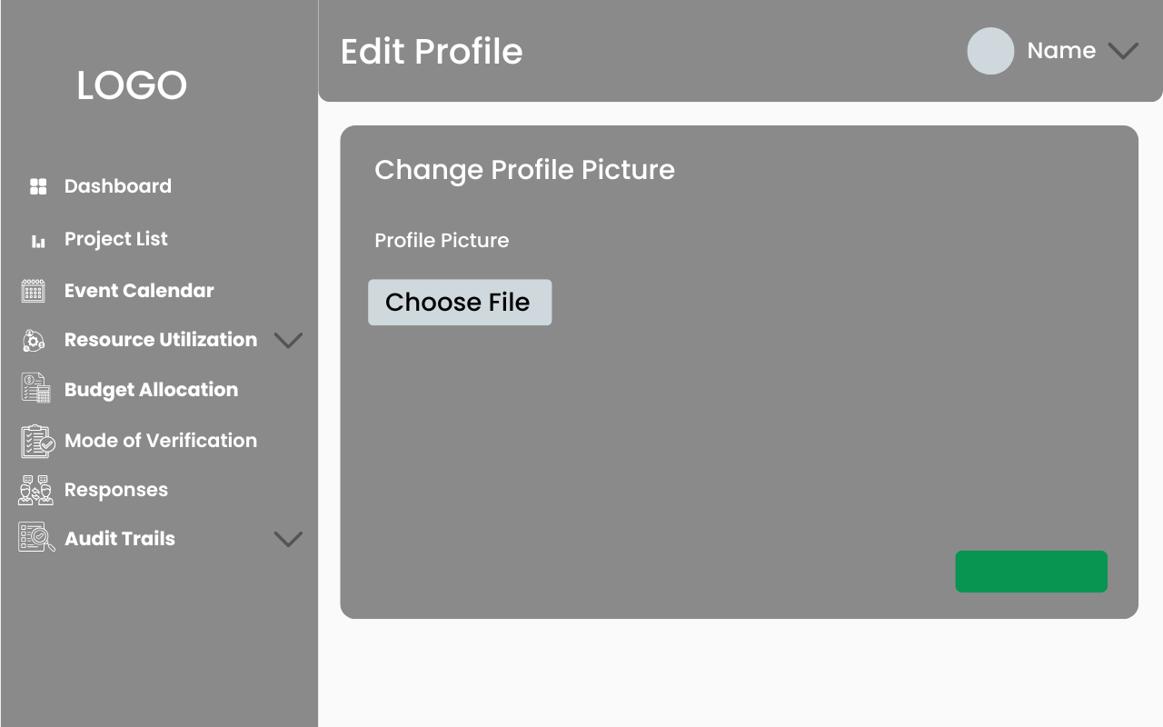

***Figure 2.5.39 Colleges / Head Edit Profile Page***

**Head Coordinator / College Coordinator**

The “Change Password” page allows both the Head Coordinator and colleges to securely update their password, ensuring account safety and privacy. 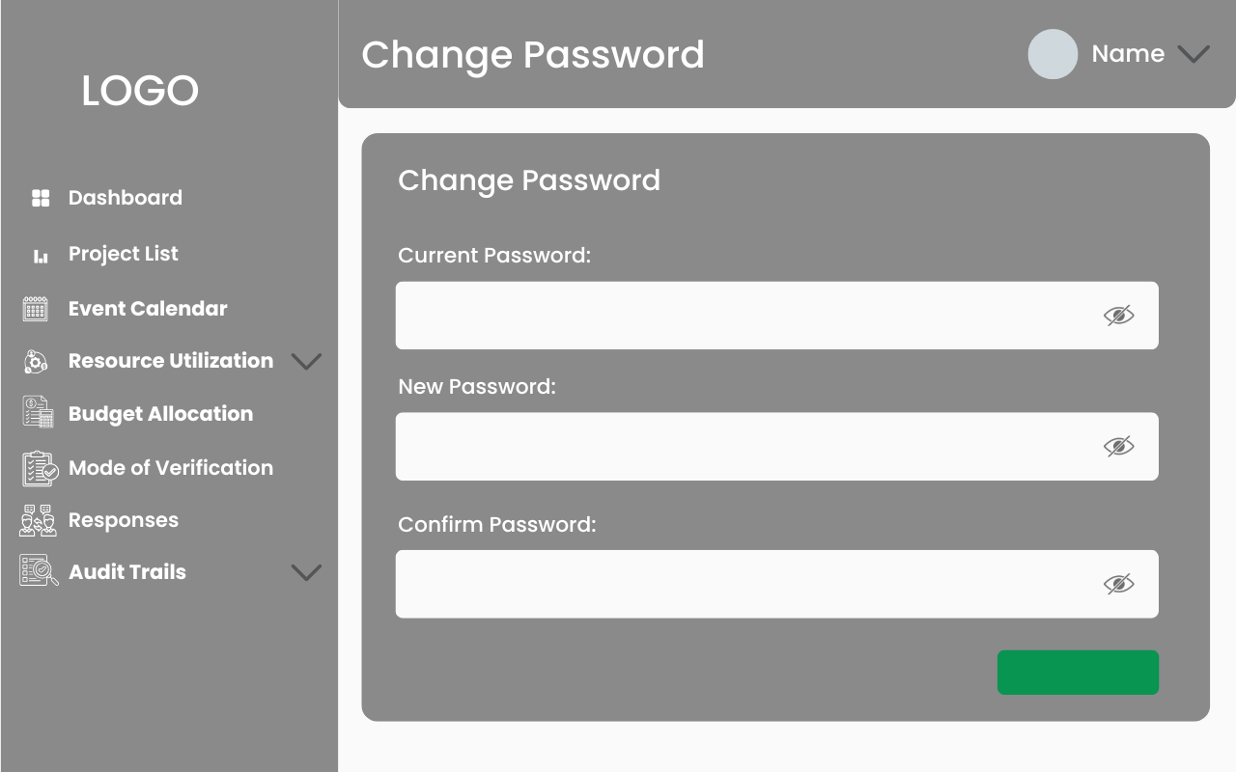

***Figure 2.5.40 Colleges / Head Change Password Page***

**CHAPTER III**

**RESULT AND DISCUSSION**

This chapter presents the project capabilities, testing process details, and the data gathered. It also provides the analysis and interpretation of the data organized according to the website’s functionality, reliability, usability, efficiency, portability, and maintainability.

**3.1 Project Capabilities and Testing Process Details**

**Project Capabilities**

The objective of this study is to formulate an Integrated System for Sustained Community Engagement at Pamantasan ng Lungsod ng Pasig in order to solve the existing inadequacies in CES's data management and Cisco powers the team’s communication. In order, this system intends to facilitate the processes of designing new projects, working together, tracking project development, improving communication, and ensuring the precision of collected information. It is hoped that the above will increase the effectiveness and reach of community initiatives through provision of a more effective, secure, and easy to use platform for the coordinators.

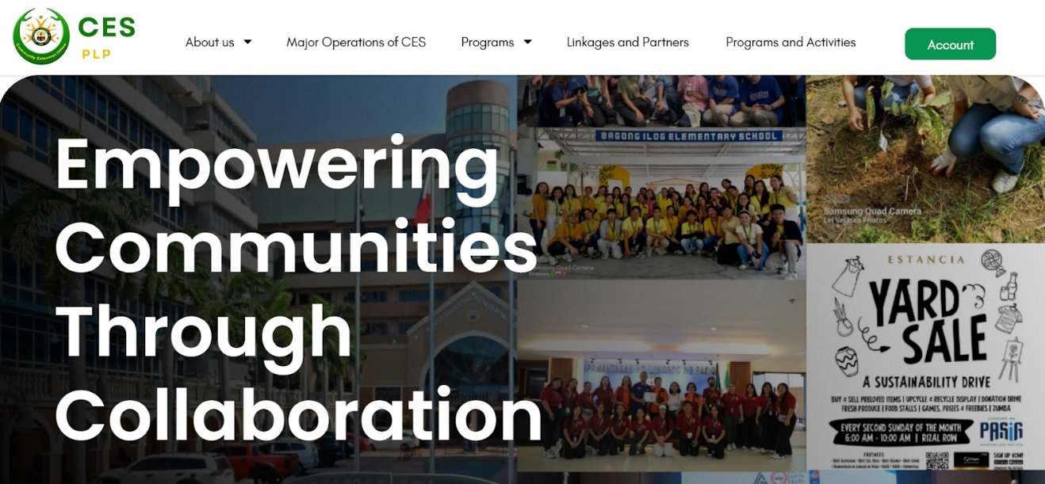**Figure 3.1.1 Main Page**

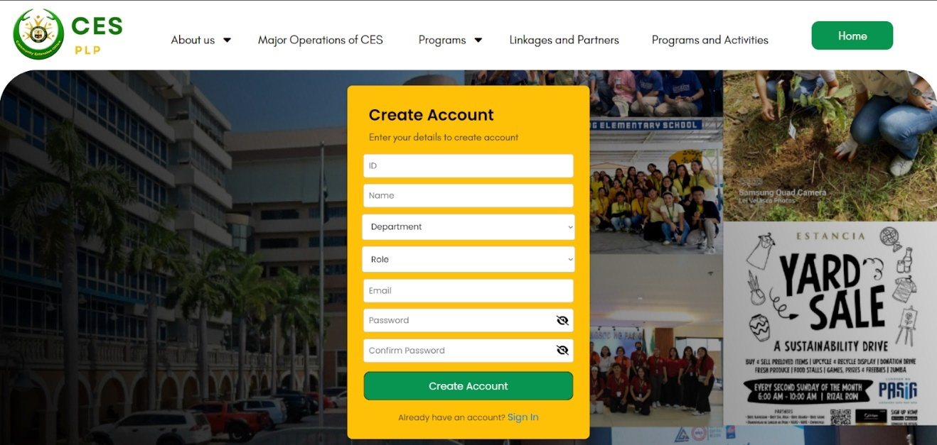The Main page displays the About us, Major Operations of CES, Programs, Linkages and Partners, and Programs and Activities. This page shows what the CES is all about and their Achievements.

**Figure 3.1.2 Create Account**

The create account form is where the user will register new accounts and determine which account is it registering as to access the system.

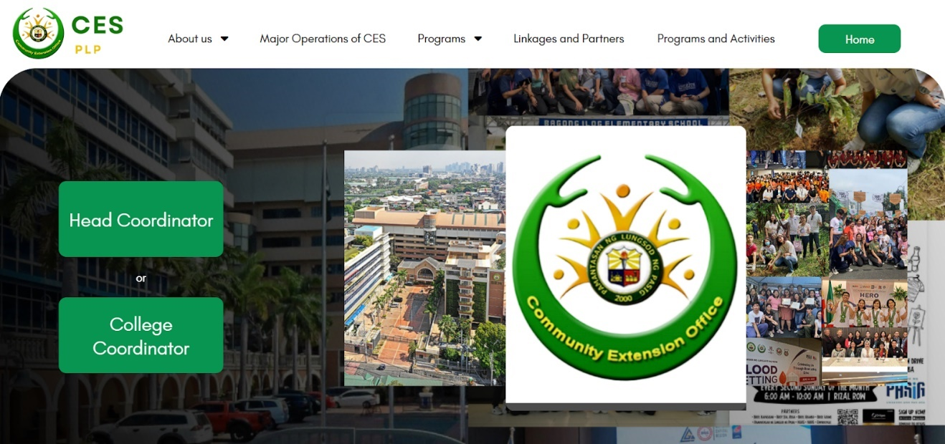**Figure 3.1.3 Role Account**

The role account will determine which user is logging as using their unique ID’s

**A. Head Coordinator Side**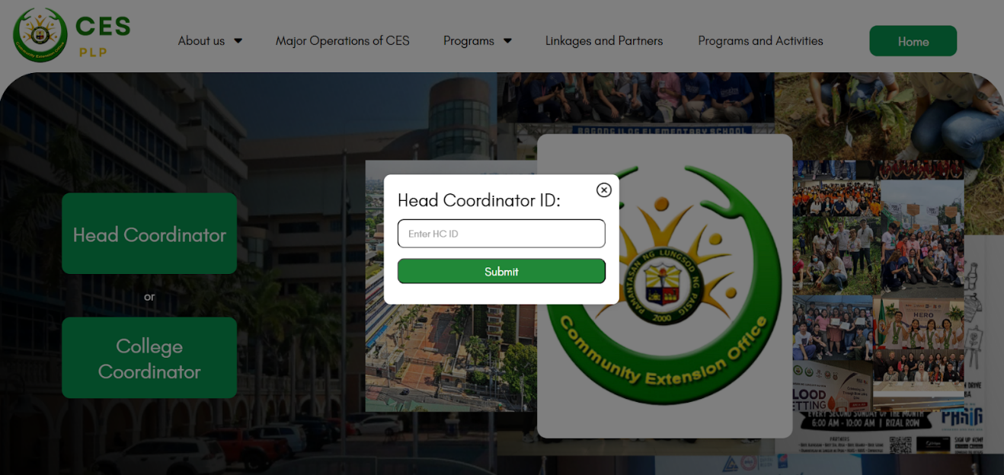

**Figure 3.1.4 Head Coordinator Role Account**

The Head coordinator inputs the registered ID.

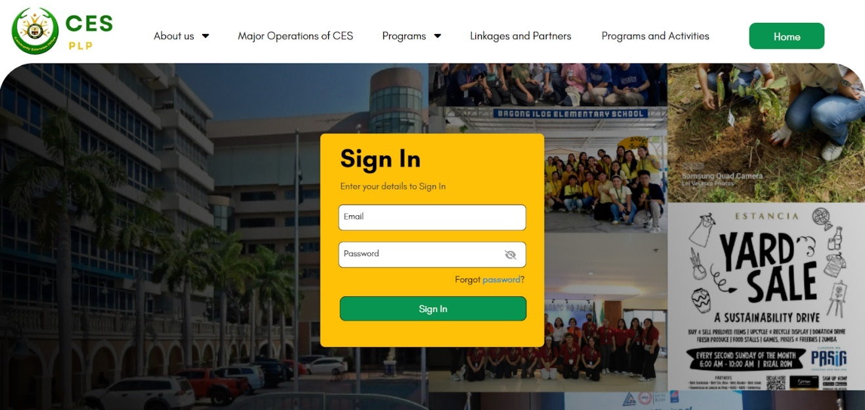**Figure 3.1.5 Head Coordinator Sign In**

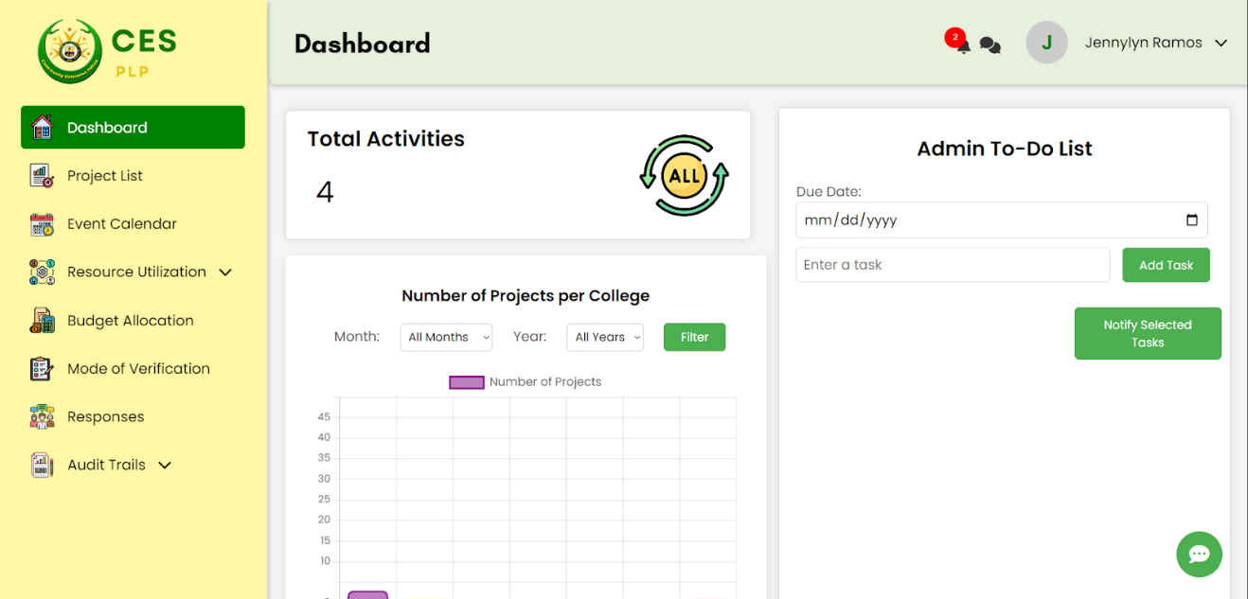The Head Coordinator inputs the registered Email and Password.

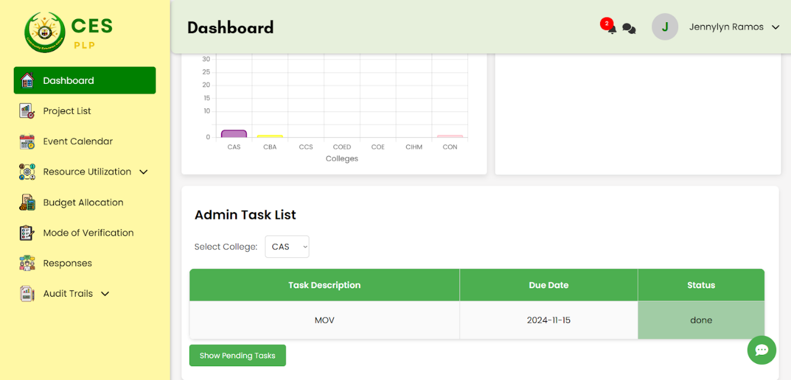  
**Figure 3.1.6 Head Coordinator Dashboard**

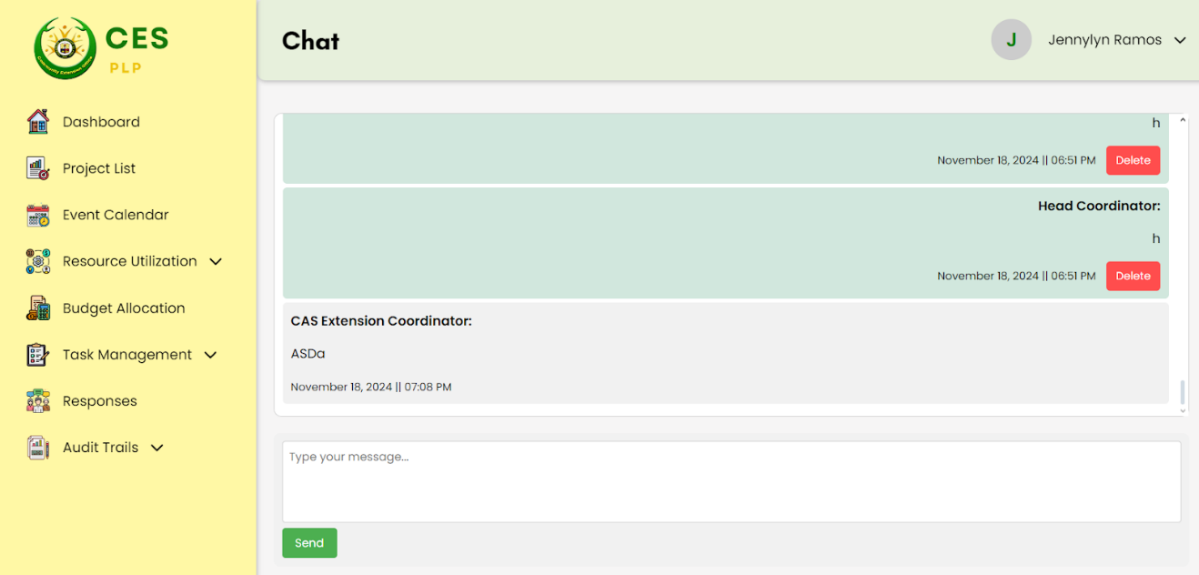Display the Graph of total projects per colleges, Task List, and Input for adding new tasks and notifying the colleges.

**Figure 3.1.7 Head Coordinator Chat**

The Head coordinator can send messages to all of the other college department coordinators.

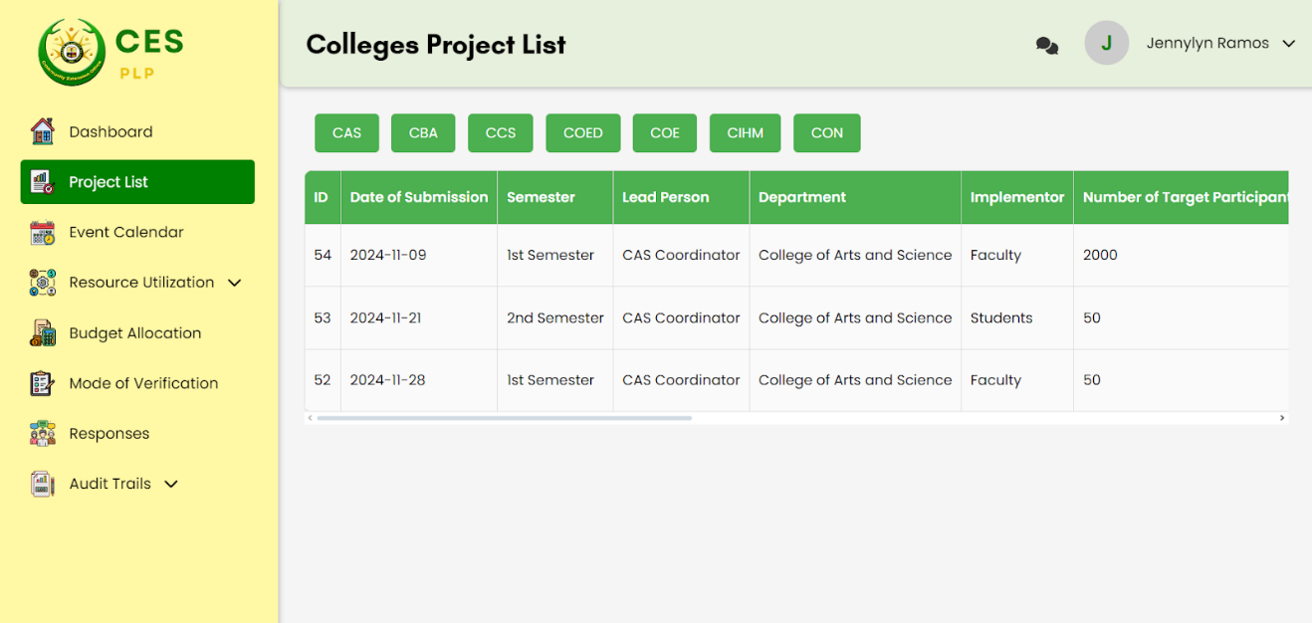  
**Figure 3.1.8 Head Coordinator Project List**

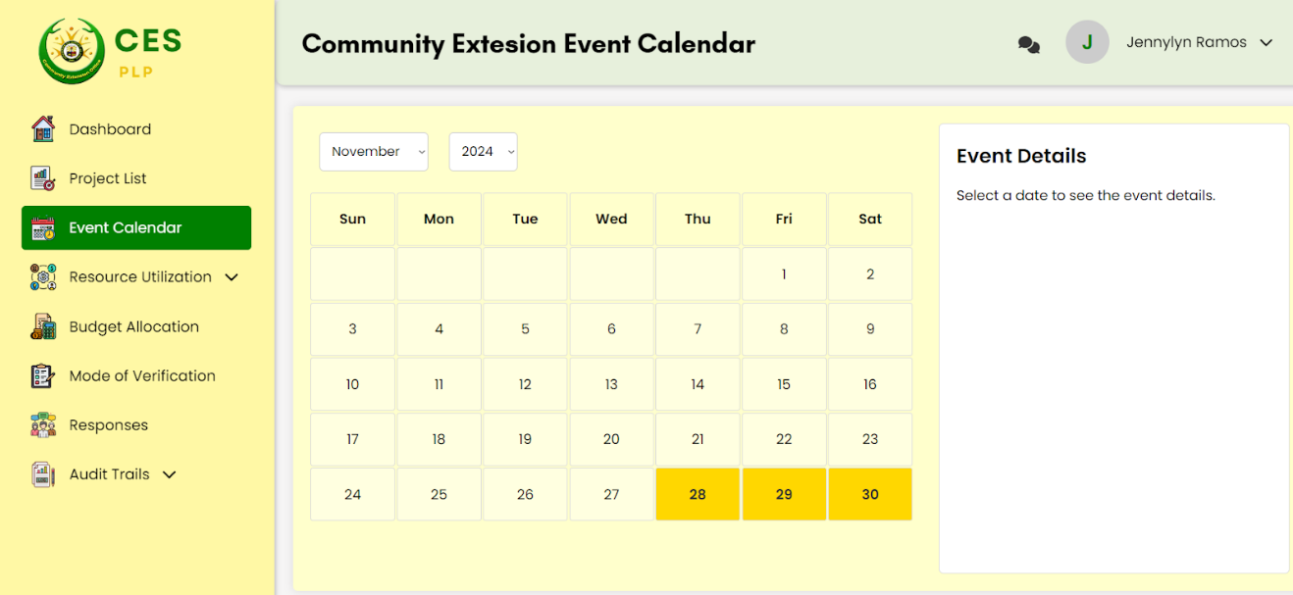Displays all the added projects/events per department, Added by the college coordinators

**Figure 3.1.9 Head Coordinator Event Calendar**

Display all the dates that have an event within that date.

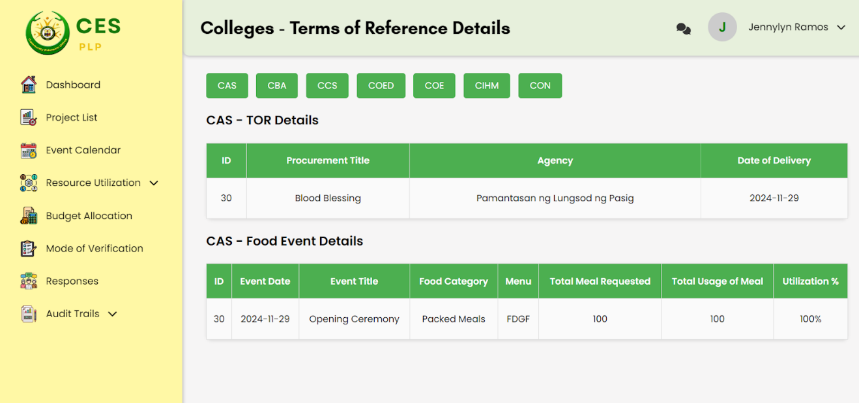**Figure 3.1.10 Head Coordinator Resource Utilization - Terms of Reference**

Displays the Terms of Reference sent by the college coordinators per department.

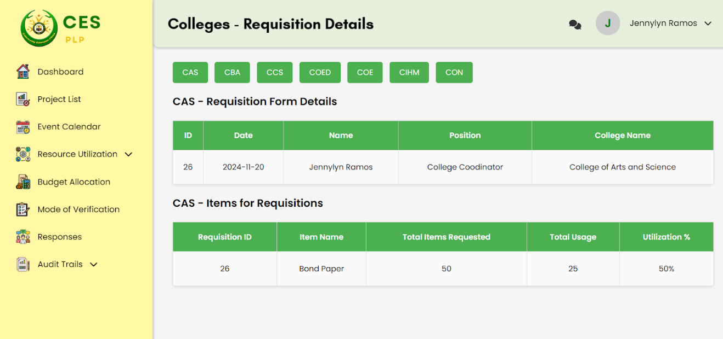  
**Figure 3.1.11 Head Coordinator Resource Utilization – Requisition**

Displays the Requisition sent by the college coordinators per department.

**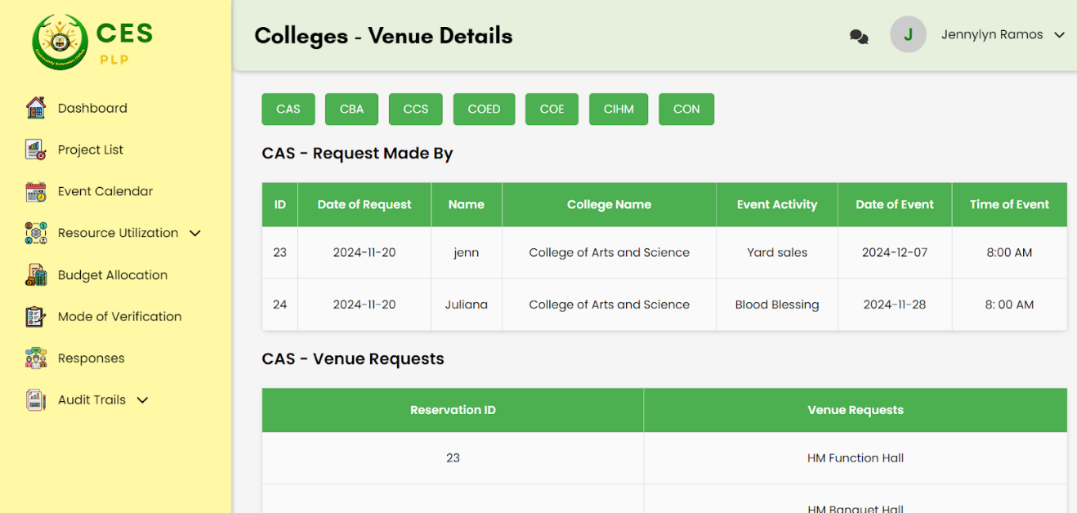  
Figure 3.1.12 Head Coordinator Resource Utilization – Venue**

Displays the Venue sent by the college coordinators per department.

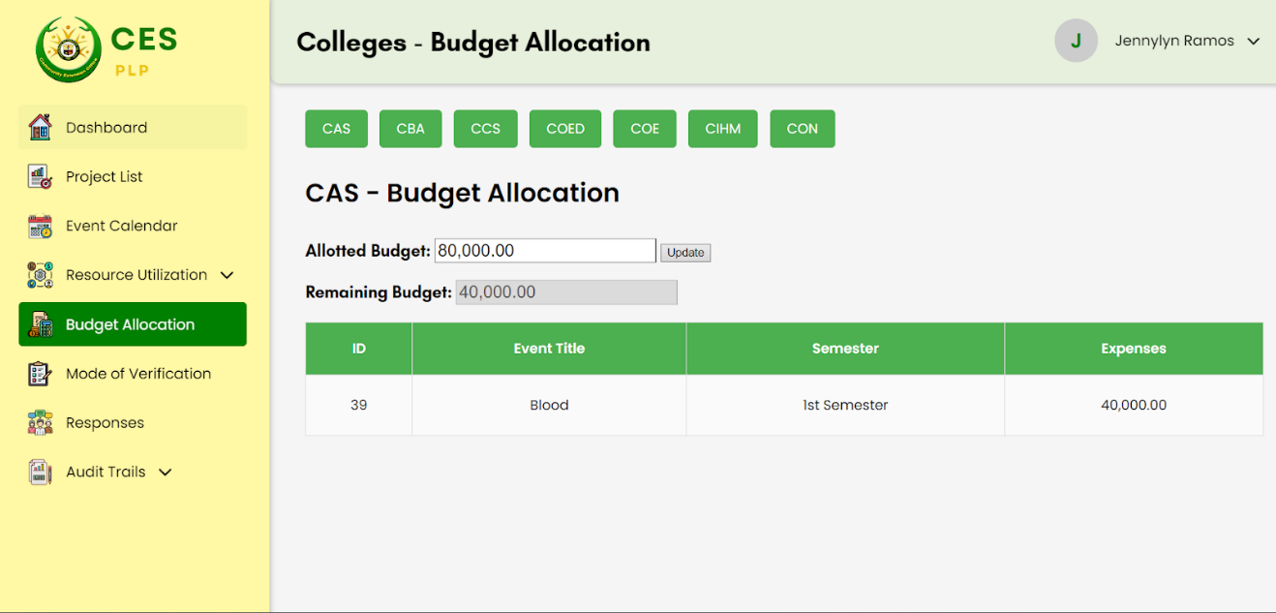**Figure 3.1.13 Head Coordinator Budget Allocation**

Displays the Allotted budget, Remaining budget, and Budget expenses of events per department.

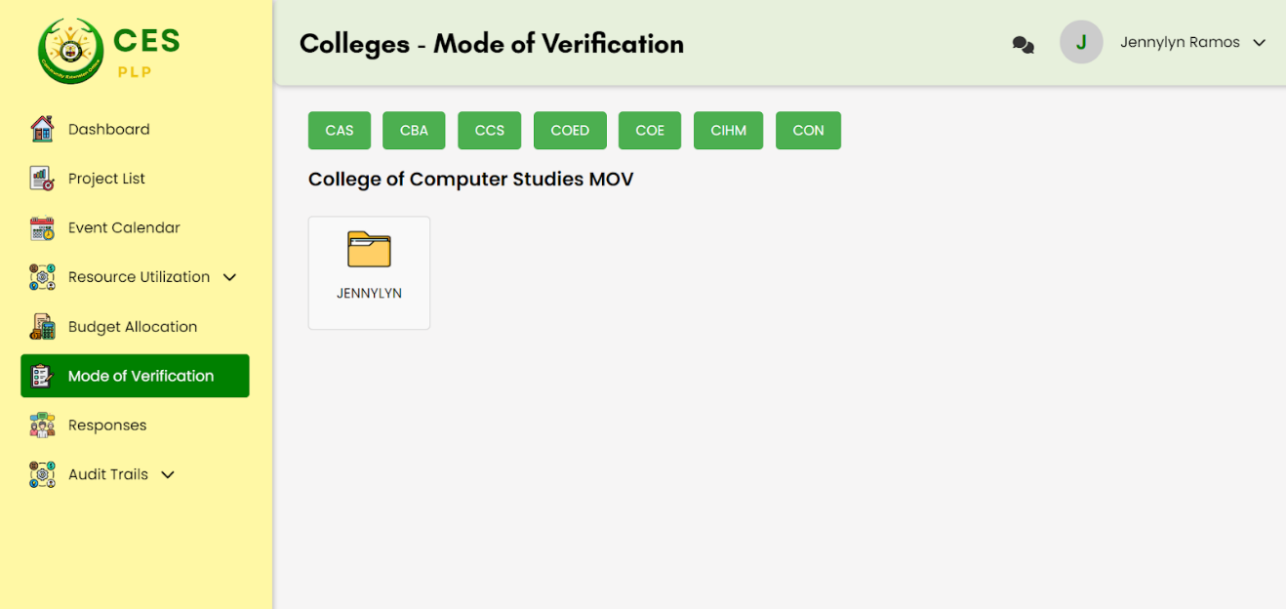  
**Figure 3.1.14 Head coordinator Mode of Verification**

Displays all the folder of the events and its containing files.

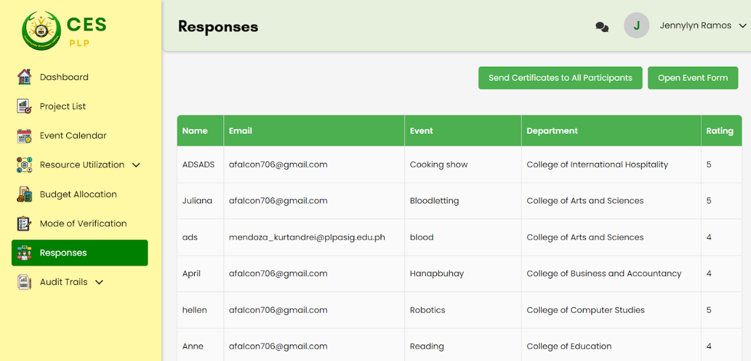**Figure 3.1.15 Head Coordinator Response**

Shows all the responses of the participants for every event that the college departments have implemented and its impact rating.

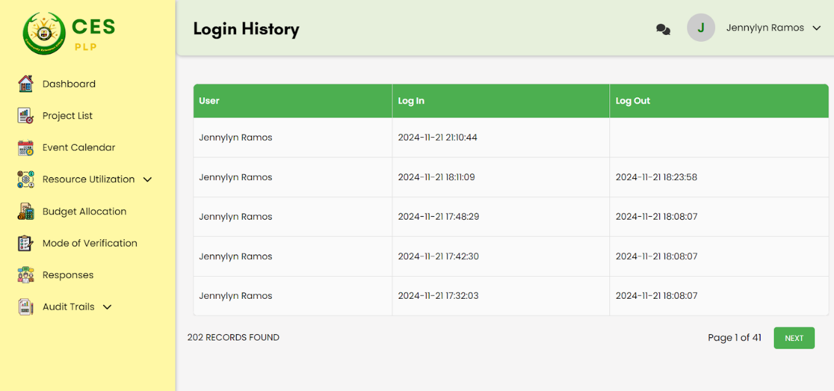**Figure 3.1.16 Head Coordinator Audit Trails - Login History**

Shows the login and log out time of the Head Coordinator.

**B. College Coordinator side**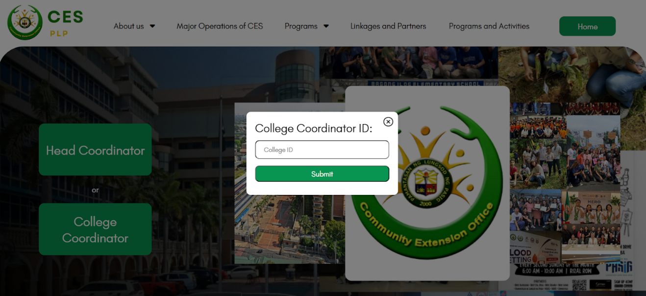

**Figure 3.1.18 College Coordinator ID**

Input the College coordinator ID.

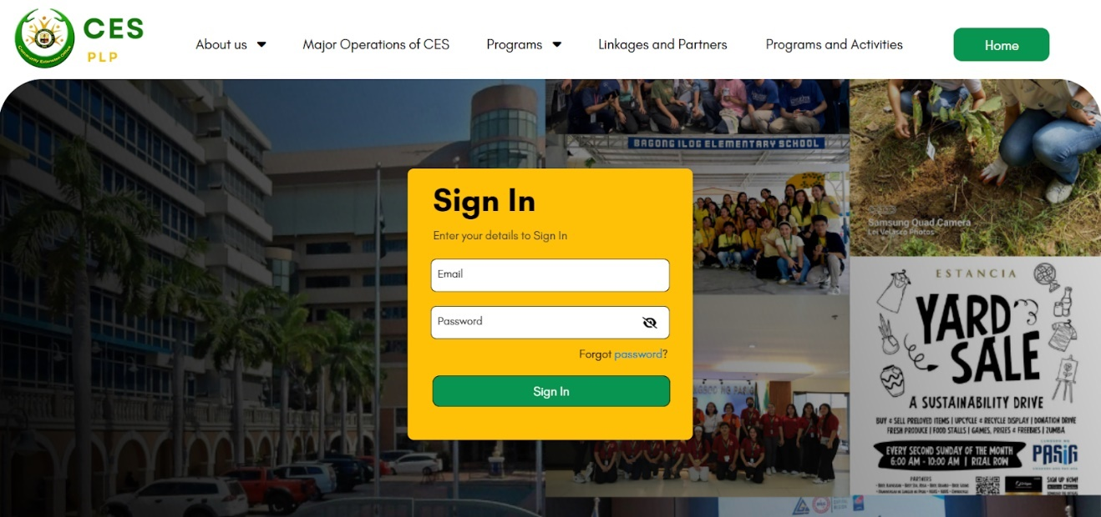

**Figure 3.1.19 College Coordinator Sign in**

Input the College coordinator registered email and password.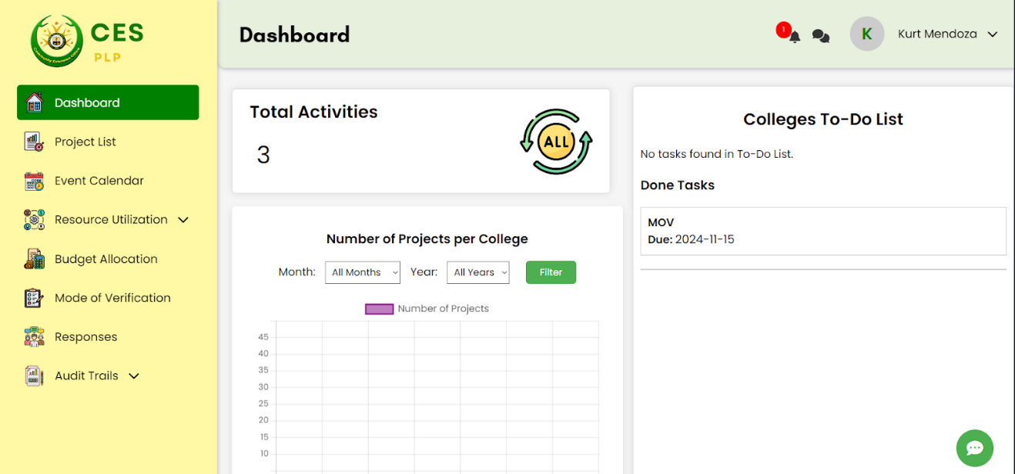

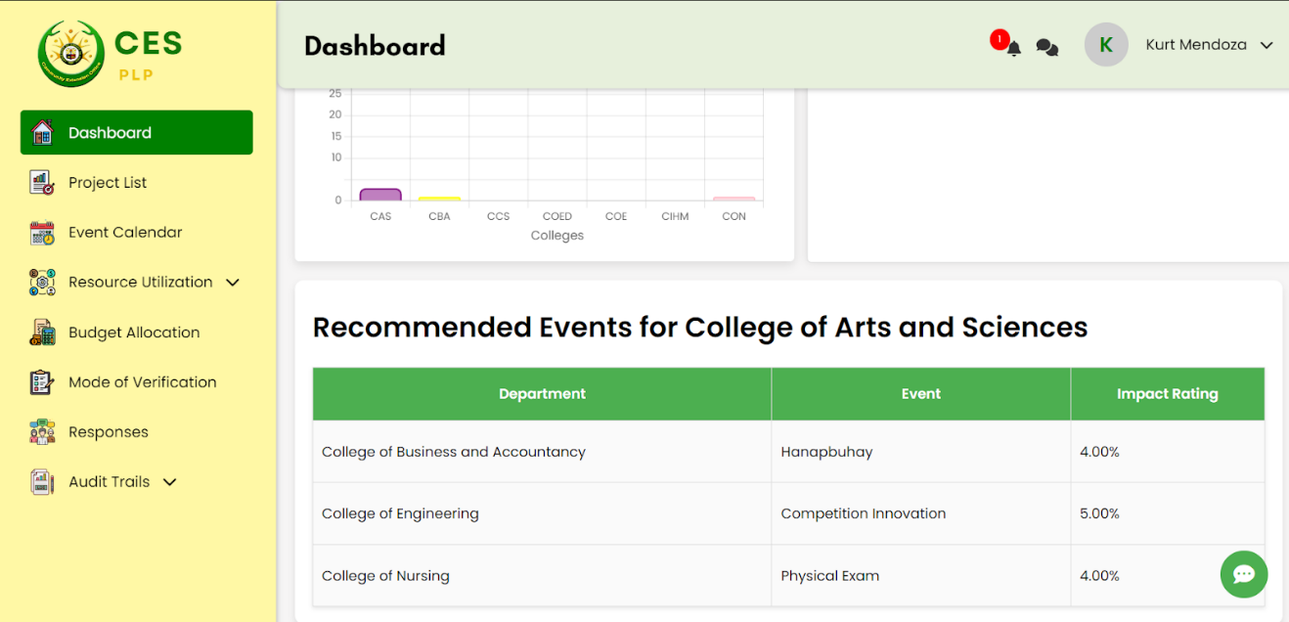

**Figure 3.1.20 College coordinator Dashboard**

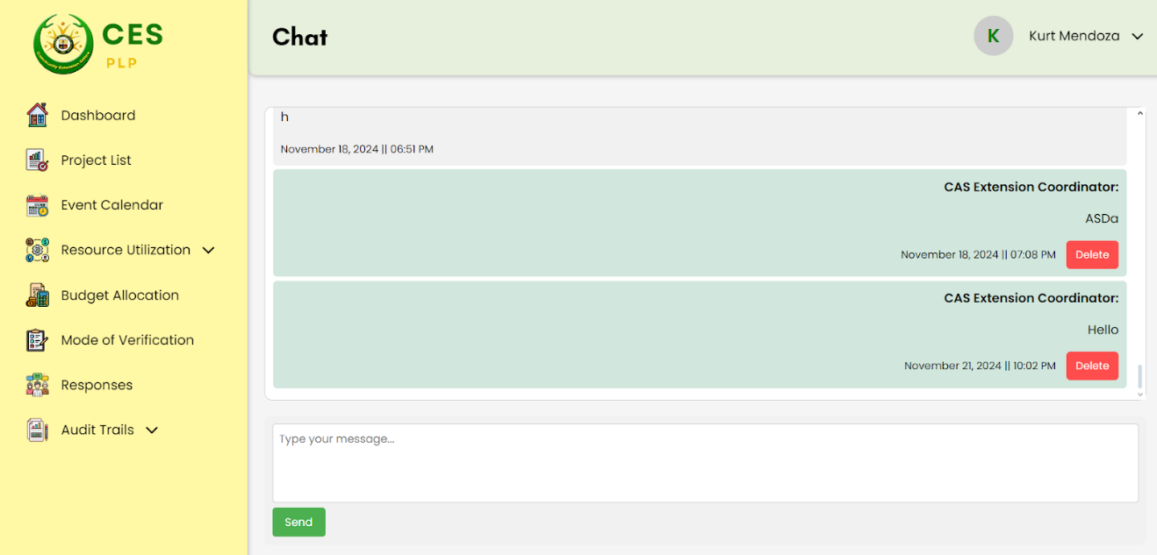Display the Graph of total projects of the college, To-do List, and Recommended events from other colleges.  
**Figure 3.1.21 College Coordinator Chat**

The College coordinator can send messages to all of the other college department coordinators as well as the Head coordinator.

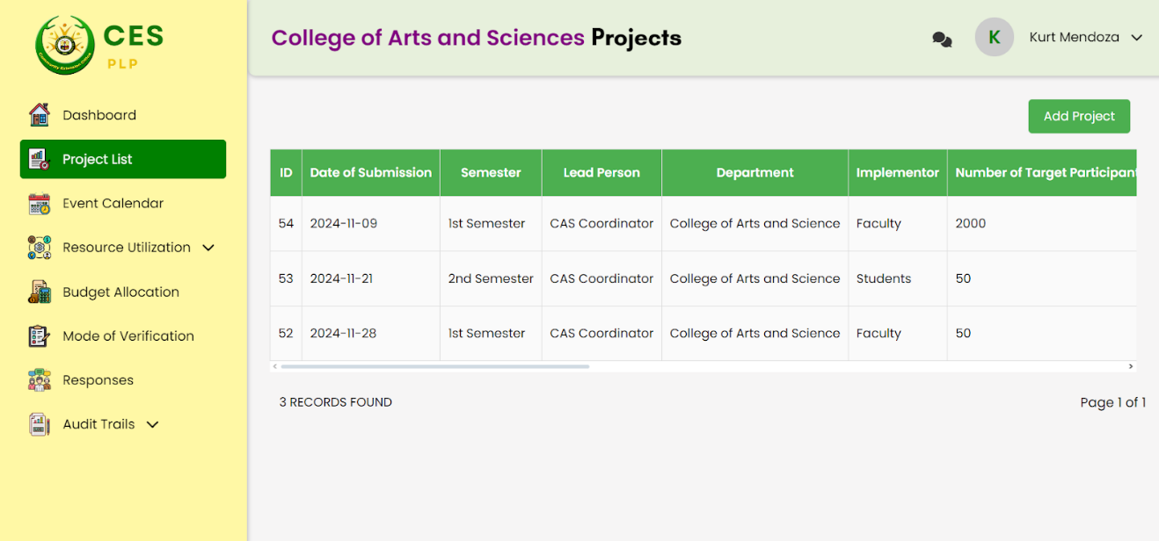**Figure 3.1.22 College Coordinator Project List**

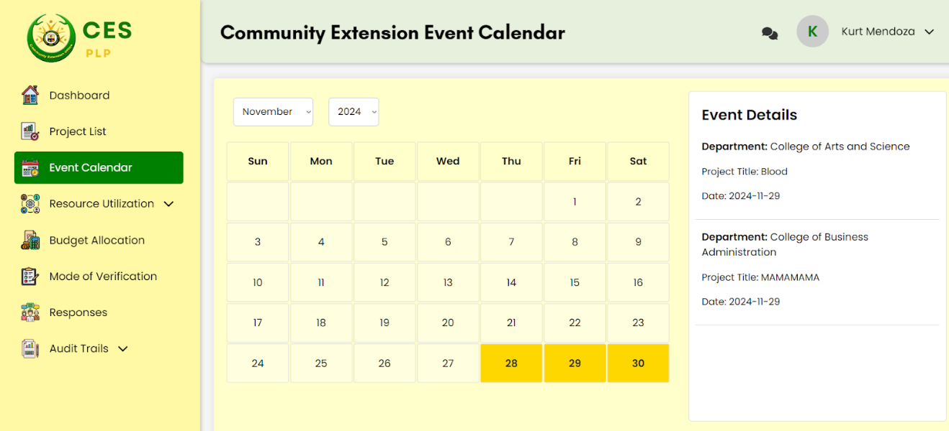Inputs the college coordinator projects details.

**Figure 3.1.23 College coordinator Event Calendar**

Display all the dates that have an event within that date.

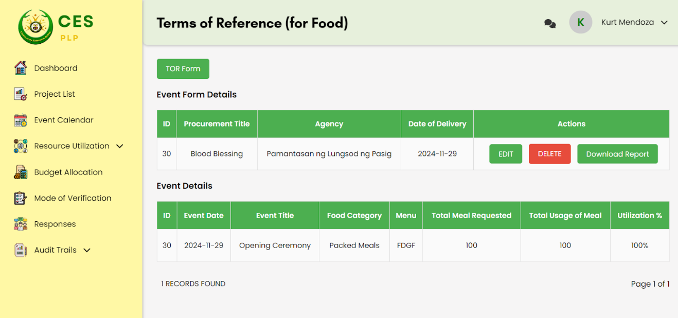**Figure 3.1.24 College Coordinator Resource Utilization - Terms of Reference**

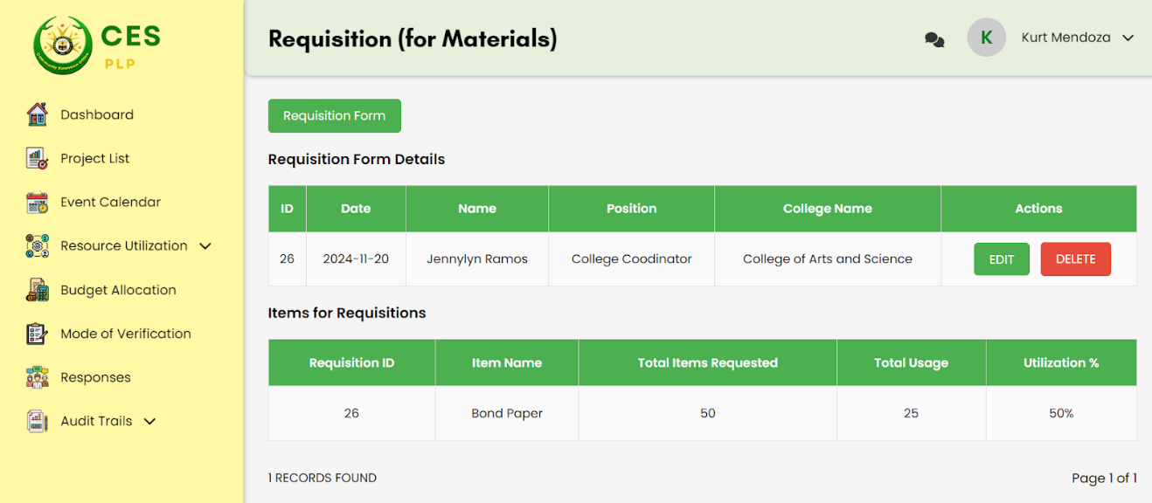Allows the college coordinator to add, edit, and delete Terms of reference attributes.

**Figure 3.1.25 College Coordinator Resource Utilization – Requisition**

Allows the college coordinator to add, edit, and delete Requisition attributes.

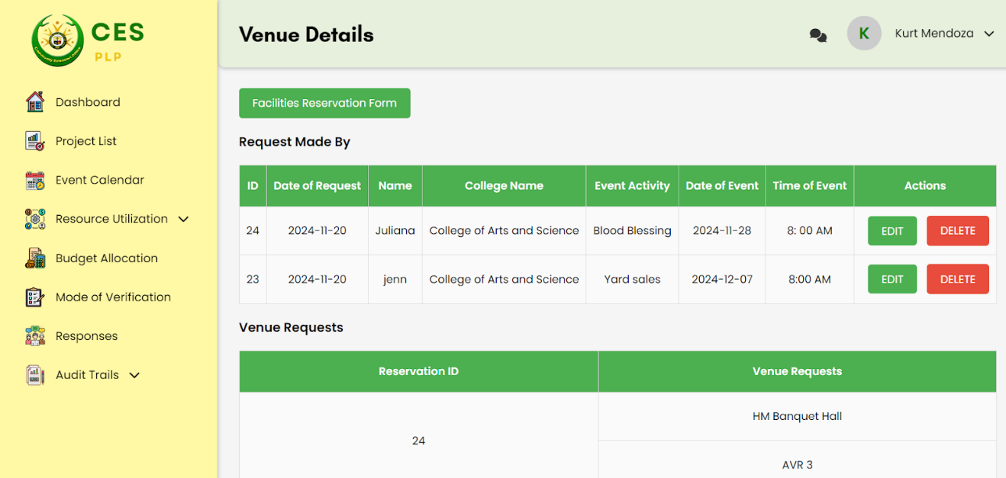  
**Figure 3.1.26 College Coordinator Resource Utilization – Venue**

Allows the college coordinator to add, edit, and delete Venue attributes.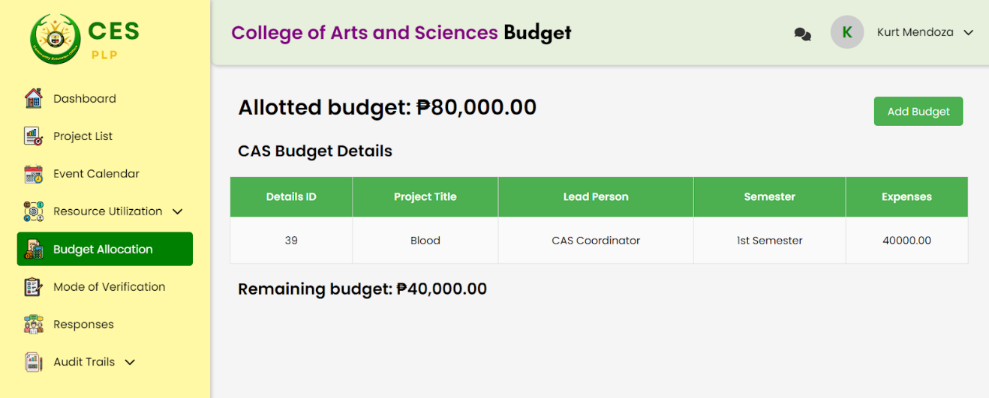

**Figure 3.1.27 College coordinator Budget Allocation**

Allows the college coordinator to Add the budget expenses for each event and see the allotted budget.

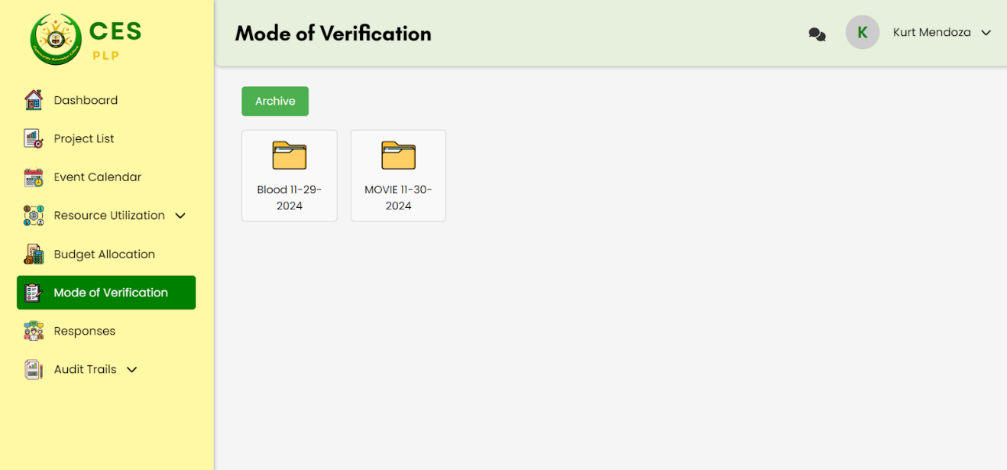

**Figure 3.1.28 College coordinator Mode of Verification**

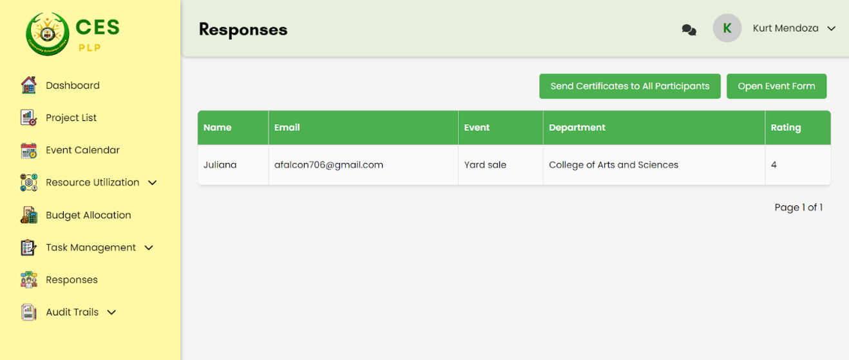Automatically create new folders for each event and consist of subfolders for uploading of files and allows the college coordinator to create new subfolders.

**Figure 3.1.29 College coordinator Responses**

Displays all of the participants' feedback for each event and displays its impact ratings and sends certificates for the participants who attended those events.

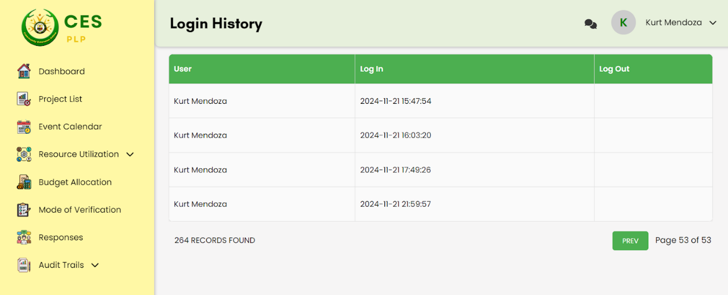

**Figure 3.1.30 College Coordinator Audit Trails - Login History**

Shows the login and log out time of the college coordinator.

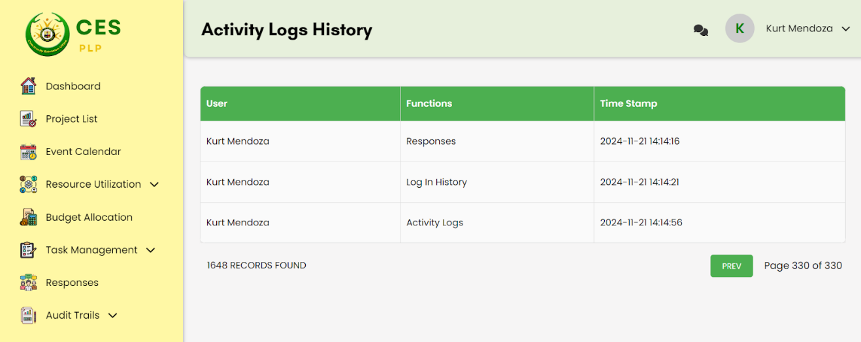

**Figure 3.1.31 College coordinator Audit Trails - Login History**

Shows all of the modules that the Head coordinator has accessed and its time stamp.

**4.2 Project Testing Results**

The Integrated System for Sustained Community Engagement has advanced programming that allows the college coordinator to support other colleges’ activities based on the success of previous events. This system not only just explains how the activities can be expected to work out but also enables the coordinators to measure the completion of community initiatives across the various units hence enhancing synergies and better planning for upcoming activities.

The researchers applied Collaborative Filtering as their algorithm for their system. Collaborative filtering (CF), which is also known as a collaborative recommendation system is in high demand, which allows one to predict what a user may like based on the choices of other people. It operates under the assumption that when two users (departments) have similar past interactions such as behaviors or ratings, they can be expected to prefer similar things in the future too.

The flow of the logic of collaborative filtering for this study:

**Evaluation of Events Based on their Rated Average**

This computes the average score received by various events across various departments, which excludes the events of the selected departments. It ensures that only the rating that expresses participants’ evaluation towards the given events and not any other factors plays a role in the preference of the events. In averaging, it helps to come up with a fair comparison of the events that probably have different rating figures with them.

**Determining the Events with the Highest Ratings**

After the average ratings have been determined, all event ratings by department are averaged, and the highest rated event of each department is selected, provided the rating of that event is above or equal to 4. This system ensures that only the best performing, most rated over the cut-off events are recommended while others that are poorly rated are left out so as to maintain quality.

𝑀 = maximum rated event

**Filtering by Similar Categories**

Events organized by departments are basically of the same theme or interest which is known as the event category. By analyzing the categories of events in the selected department against those of other departments, the system is able to detect departments with similar interests. For this reason, this stage ensures that the user events recommended are appropriate with regards to the user department by looking at the events from the departments that have similar categories.  
  
For the selected department (𝑆), identify all departments (𝐷′) that share at least one common category in their event lists:

Where the set intersection is indicated by ∩.

**Filtering the Recommended Events**

After the events rated the highest are detected and the departments that are compatible similar are established, the next step is to narrow down the events to include only the ones that are from departments that profile similar to the selected department by sharing categories. This guarantees that the suggestions provided are of high quality and also appropriate to the area of concern for the user.

𝐸 (an event) is included in the set 𝑀 (maximum-rated events) if the department 𝐷 (where the event belongs) is in the set of Similar Departments.

After these processes, Events that have been filtered will be displayed in a simple and straightforward list, only featuring the top-rated events of departments that have common interest. This last step enables the user to efficiently search for events that suit their preferences and are of high quality, thus enhancing the quality of the experience of the user overall.

**4.3 Test plan**

The significance of the testing for the implementation of a Community Extension Services integrated system. revolved around evaluating the performance, usability, and essential features. In order to address particular system components that matched user expectations and organizational goals, the test focus was established. These consist of:

1. System Functionality in Meeting User Needs:

* Testing was done to ensure that the system successfully serves the main goals of Community Extension Services, including tracking progress, managing project events, and ensuring that collaborative filtering recommendations are recommending events on point.

1. Responsive to User Inputs:

* The system's ability to react quickly to user input was essential. This part of the testing procedure confirmed that the system processes data quickly and accurately, guaranteeing smooth navigation and real-time feedback. To ensure a seamless user experience, input validation and error management were also investigated, such as uploading of MOVs and recovery of archived files.

1. Integration between Modules:

* One of the primary objectives was to ensure that several modules, including the project list, resource utilization, mode of verification, and event calendar, functioned together seamlessly. Testing verified data consistency, synchronization, and proper transferring information between components, which decreased redundancy and improved efficiency.

1. User Interface and Experience:

* The system's user interface was assessed for usability and ease of use. This involved testing user interaction, layout design, and accessibility. Ensuring that users of various technical skill levels could efficiently browse and use the system was intended to increase user satisfaction.

1. Recommendation Accuracy of Collaborative Filtering:

* For the system employing collaborative filtering to predict highly impactful events, Testing assesses the advice' validity and precision. This involved comparing events made from other departments  and validating algorithms for reliability.

1. System Security:

* To find weaknesses and protect sensitive data, a thorough testing is done. This guarantees that the system satisfies security requirements, safeguards user data, and upholds data confidentiality and authenticity.

The significance of the testing for the implementation of a Community Extension Services integrated system. revolved around evaluating the performance, usability, and essential features. In order to address particular system components that matched user expectations and organizational goals, the test focus was established. These consist of:

**A. System Functionality in Meeting User Needs:**

* Testing was done to ensure that the system successfully serves the main goals of Community Extension Services, including tracking progress, managing project events, and ensuring that collaborative filtering recommendations are recommending events on point.

**B. Responsive to User Inputs:**

* The system's ability to react quickly to user input was essential. This part of the testing procedure confirmed that the system processes data quickly and accurately, guaranteeing smooth navigation and real-time feedback. To ensure a seamless user experience, input validation and error management were also investigated, such as uploading of MOVs and recovery of archived files.

**C. Integration between Modules:**

* One of the primary objectives was to ensure that several modules, including the project list, resource utilization, mode of verification, and event calendar, functioned together seamlessly. Testing verified data consistency, synchronization, and proper transferring information between components, which decreased redundancy and improved efficiency.

**D. User Interface and Experience:**

* The system's user interface was assessed for usability and ease of use. This involved testing user interaction, layout design, and accessibility. Ensuring that users of various technical skill levels could efficiently browse and use the system was intended to increase user satisfaction.

**E. Recommendation Accuracy of Collaborative Filtering:**

* For the system employing collaborative filtering to predict highly impactful events, Testing assesses the advice' validity and precision. This involved comparing events made from other departments and validating algorithms for reliability.

**F. System Security:**

* To find weaknesses and protect sensitive data, a thorough testing is done. This guarantees that the system satisfies security requirements, safeguards user data, and upholds data confidentiality and authenticity.

The system's end users were the Head Coordinators, College Coordinators, IT professionals, all of whom were baseline participants who had a usage experience that relates directly with the study. In regard to the project, the researchers used the framework for the evaluation that was based on ISO 9126 that involved system characteristics including functionality, dependability, usability, efficiency, portability and maintainability. They enhanced the system to these further outputs.

**Legend:**

|  |  |  |
| --- | --- | --- |
| **Rating** | **Scale** | **Verbal Interpretation (IV)** |
| 4 | 3.50 – 4.00 | Strongly Agree |
| 3 | 2.50 – 3.49 | Agree |
| 2 | 1.50 – 2.49 | Disagree |
| 1 | 1.00 – 1.49 | Strongly Disagree |

**WM -** Weighted Mean

**VI -** Verbal Interpretation

|  |  |  |
| --- | --- | --- |
| **Functionality** | **User** | |
| **WM** | **VI** |
| Suitability | 4.00 | SA |
| Accurateness | 3.57 | SA |
| Security | 3.82 | SA |
| **Overall Values:** | **3.80** | **SA** |

# **Table 4.2.1 Assessment of the Functionality of the System**

Table 4.2.1 represents the assessment of the functionality of the system. Based on the results of the researchers, the overall values of the system mean Strongly Agree (SA) and have a weighted mean of 3.80. The functionality and operation of Integrated System for Community Extension Services satisfied the responders.

|  |  |  |
| --- | --- | --- |
| **Reliability** | **User** | |
| **WM** | **VI** |
| Fault Tolerance | 4.00 | SA |
| Recoverability | 4.00 | SA |
| **Overall Values:** | **4.00** | **SA** |

# **Table 4.2.2 Assessment of the Functionality of the System**

Table 4.2.2 represents the assessment of the functionality of the system. Based on the results of the researchers, the overall values of the system mean Strongly Agree (SA) and have a weighted mean of 4. The system met the respondents' expectations, and they were satisfied with its reliability.

|  |  |  |
| --- | --- | --- |
| **Usability** | **User** | |
| **WM** | **VI** |
| Understandability | 4.00 | SA |
| Learnability | 4.00 | SA |
| Operability | 3.73 | SA |
| Attractiveness | 3.87 | SA |
| **Overall Values:** | **3.90** | **SA** |

# **Table 4.2.3 Assessment of the Usability of the System**

Table 4.2.3 represents the assessment of the Usability of the system. Based on the results of the researchers, the overall values of the system mean Strongly Agree (SA) and have a weighted mean of 3.90. The respondents were satisfied and did not have a hard time navigating the system. This just indicates that the system was user-friendly and simple to operate.

|  |  |  |
| --- | --- | --- |
| **Efficiency** | **User** | |
| **WM** | **VI** |
| Time Behaviour | 4.00 | SA |
| Resource Utilization | 4.00 | SA |
| **Overall Values:** | **4.00** | **SA** |

**Table 4.2.4 Assessment of the Efficiency of the System**

Table 4.2.4 represents the assessment of the Efficiency of the system. Based on the results of the researchers, the overall values of the system mean Strongly Agree (SA) and have a weighted mean of 4. This indicates that respondents were satisfied with how quickly and efficiently data is processed and displayed on the system's various modules.

|  |  |  |
| --- | --- | --- |
| **Portability** | **User** | |
| **WM** | **VI** |
| Installability | 3.87 | SA |
| Replaceability | 3.87 | SA |
| **Overall Values:** | **3.87** | **SA** |

**Table 4.2.5 Assessment of the Portability of the System**

Table 4.2.5 represents the assessment of the Portability of the system. Based on the results of the researchers, the overall values of the system mean Strongly Agree (SA) and have a weighted mean of 3.87. This shows that the system is highly adaptable across different environments or platforms meeting portability standards effectively.

|  |  |  |
| --- | --- | --- |
| **Maintainability** | **User** | |
| **WM** | **VI** |
| Analyzability | 3.87 | SA |
| Testability | 3.87 | SA |
| **Overall Values:** | **3.87** | **SA** |

**Table 4.2.6 Assessment of the Maintainability of the System**

Table 4.2.6 represents the assessment of the Maintainability of the system. Based on the results of the researchers, the overall values of the Maintainability of the system mean is Strongly Agree (SA) and have a weighted mean of 3.87.

|  |  |  |
| --- | --- | --- |
| **System Evaluation** | **User** | |
| **WM** | **VI** |
| Functionality | 3.80 | SA |
| Reliability | 4.00 | SA |
| Usability | 3.90 | SA |
| Efficiency | 4.00 | SA |
| Portability | 3.87 | SA |
| Maintainability | 3.87 | SA |
| **Overall Values:** | **3.91** | **SA** |

**Table 4.2.7 Assessment of the respondents to the system**

Table 4.2.7 represents the assessment of the respondents to the system. The data that the researchers have acquired indicates the system's total value is Strongly Agree (SA), and it has a 3.91 as the overall weighted mean. This indicates that respondents were satisfied that the system's performance is evaluated according to its functionality, reliability, efficiency, portability, maintainability, and usability.

**CHAPTER IV**

**Conclusion and Recommendations**

This chapter covers a summary of the research that was conducted, the findings that were drawn, and recommendations that were put out as a result. The Integrated system for community engagement at Pamantasan ng Lungsod ng Pasig is the subject of this study.

**4.1 Conclusions**

The primary purpose of this study is to Strengthen Collaborative Initiatives Among Departments at Pamantasan ng Lungsod ng Pasig.

The Integrated System for Sustained Community Engagement proposed at Pamantasan ng Lungsod ng Pasig (PLP) presents solutions to the distressing problems that are experienced by the Community Extension Service (CES) with regard to data handling, communication or collation of projects. The aim of this system is to eliminate cascading from isolated platforms such as Google Drive, Excel or Messenger into an all-inclusive, custom-made solution to assist in rendering CES activities more efficient and effective. This new approach will not only make the management and implementation of projects and communication more orderly, but also ensure lasting solutions to community projects. In addition, it will enhance the capacity of Community Extension Coordinators through provision of a comprehensive model of active learning and real-time evaluation of effects. At the end, the system will complement the existing developmental mission of PLP and contribute to effective working relationships that will affect convergence and community development.

The Integrated System for Sustained Community Engagement validation framework action plan at Pamantasan ng Lungsod ng Pasig (PLP) has a Project List module allowing the Head Coordinator to effectively track and monitor the community engagement projects per department. For this purpose, College Coordinators also included the project’s agreed budget, personnel input and the timelines. The Head Coordinator made use of this module in order to keep track of all the current projects and make sure that the budgets, resources and timelines, which were established, were utilized. This system does a good job because different regions replaced diverging tools that communicated through Google Drive, Excel and messenger for communication and information management and all activities are carried on the same platform that supports the web based system. It made it possible to monitor and evaluate the project outcomes immediately which increases the degree of the Community Extension Coordinators capacities and assists in the achievement of the PLP’s mission of promoting convergence and sustainable development. It was also able to provide the departments with better accountability, improved coordination and give long-lasting influence for all the community endeavors for every department.  
  
 With the aim of promoting inter-departmental working on the Pamantasan ng Lungsod ng Pasig (PLP), the proposed system incorporated a chat module which allowed College Coordinators to speak to one another amidst different departments. The module promoted seamless collaboration as coordinators were able to interact with one another in order to explore project specifications, offer perspectives as well as seek solutions to problems. Furthermore, the system had a recommendation system which presented previously accomplished projects and initiatives of other colleges that were related or had similar objectives. This enabled college coordinators to draw from the successful experiences of other institutions in their departments, hence enhancing collaboration and sharing of resources and best practices. With the incorporation of such features, the system made it possible for more coordinated working of departments, improved coordination among the members of departments and enhanced the community development projects undertaken at PLP by the colleges.

To efficiently manage community engagement activities at Pamantasan ng Lungsod ng Pasig (PLP), the proposed system enabled the Head Coordinator to be proactive and supervise and control all project components. The Head Coordinator was provided with data about the real-time expenditure of resources on a timely basis, which means that each department was able to effectively utilize its staff, funds and time. To some extent, because of the system, the Head Coordinator also possessed the ability to check the status of active activities to determine whether the intended schedule and targets of projects have been achieved. Integrated evaluation tools of the system were helpful in determining the relevance of these community engagement activities by providing immediate feedback, and prediction of the impact on the community and the university including the sustained impact of these activities. As this information was consolidated by the system, it allowed effective management and good planning to be undertaken in such a way that projects were meaningful and sustainable and resources were not wasted but benefits were delivered to the PLP and the community that it served.

In order to perform such a duty in each of the units, the developed system provided for a notification module which was used to remind both the Head Coordinator and the College Coordinators. Such notifications were communicated a few days before the end dates of projects and at the end of any other activity, so that no task was left unattended. Last but not least, the system included the structure of the Event Calendar module with a view enabling coordinators to see all events including from other departments. This calendar showed events in the days they are supposed to take place, thus enabling coordinators to be more organized and better coordinate activities and events in different departments. This helped eliminate the recurrence of the events by sending messages and an overview of the occurrences, thus the system ensured that all events were well executed and completed within the required time, improving inter departmental planning and cooperation.

The Integrated System for Sustained Community Engagement at Pamantasan ng Lungsod ng Pasig (PLP) proposed herein successfully addressed the issues concerning tracking of a project, resource allocation, collaboration and communication affecting the coordinators from the College and the Head coordinator. Using features such as the module for a project list, chat system, and event calendar, the system allows for the effective management and coordination of community engagement activities in planning, real-time evaluation, and the sharing of best practices. It also worked towards long-term sustainability in terms of the impact it generated within the community. The evaluation of the respondents of the system, with a weighted mean of 3.91, reflects a high level of satisfaction, as they strongly agreed on the system's overall value in terms of functionality, reliability, efficiency, portability, maintainability, and usability. This feedback confirms that the system effectively met the needs of PLP’s community extension efforts and contributed to the success of its programs.

**4.2 Recommendations**

Based on the study's findings, the following recommendations were made:

* The developers suggest that allow the users to sort/filter the data for better decision making.
* The developers suggest having better data retrieval for more efficient user interaction.
* The developers suggest allowing the college's coordinator to create their own evaluation forms for the participants of their events.
* Allow the College coordinator to create their own template for the sending of certificates to the participants of the events.
* The developers suggest allowing the users to customize their download of reports.

# **References:**

* Guiron, C. V., Abrigo, A. J. M. J., Dalmacio, J. C., Bangcoro, R. A. T., Villarosa, M. F., & Felicen, S. S. (2019, January). Participation and Attitudes of Community Extension Officers Towards Community Development.<https://research.lpubatangas.edu.ph/wp-content/uploads/2019/07/APJEAS-2019.6.1.06.pdf>.
* Kumar, P., Maring, T. O., Gaurav, S., & Ahamed, A. (2023). Assessing impact: Monitoring and evaluating extension programs. ResearchGate. <https://www.researchgate.net/publication/379311143_Assessing_Impact_Monitoring_and_Evaluating_Extension_Programs>
* Montebon, R. L., Villarante, C. P., Feliciano, T., Ocariza, R. D. P., Lopez, M. T., & Bachanicha, R. M. (2023, April). Community extension profiling of student-volunteers of the ... <https://www.ajmrd.com/wp-content/uploads/2023/04/C541621.pdf>
* Corpuz, D. A., Time, M. J. C., & Afalla, B. T. (2022). Empowering the community through the extension services of a teacher education institution in the Philippines. Cogent Education, 9(1).<https://doi.org/10.1080/2331186x.2022.2149225>
* Koekkoek, A., Van Ham, M., & Kleinhans, R. (2021, March 31). Unraveling University-Community Engagement: A Literature review. <https://openjournals.libs.uga.edu/jheoe/article/view/1586>
* Magnaye, R. P., & Ylagan, A. P. (2021, September.). Effectiveness and Impact of Community Extension Program of One Philippine Higher Education Institution as Basis for Sustainability.

[http://apjarba.apjmr.com/wp-content/uploads/2021/09/2-APJARBA-2021-27.pdf](https://l.messenger.com/l.php?u=http%3A%2F%2Fapjarba.apjmr.com%2Fwp-content%2Fuploads%2F2021%2F09%2F2-APJARBA-2021-27.pdf&h=AT3A84Fme6q913JVZFGib9nBlMpumiVswYz1xRItOczbpzguz5dhGBuvfIn0BdiEGyYbDiJQGXnRgFe73lpo25uoVXg73zEyvPN_-cBwi9nmDlSfH0xvvEDSA-TgWVJ1tpeiXg)

* Salazar, T. (2020, May). (PDF) an impact study of the community extension programs in a State College in the Philippines.

<https://www.researchgate.net/publication/342757198_An_Impact_Study_of_the_Community_Extension_Programs_in_a_State_College_in_the_Philippines>

* Mores, L. S., Lee, J., & Bae, W. (2019, March 27). University-Community Partnerships: A local planning co-production study on Calabarzon, Philippines. MDPI.

<https://www.mdpi.com/2071-1050/11/7/1850>

* Santiago, C. J., Manuel Jr., A., Ferrer, A., Reyes, J., Malabag, B., & Cahapin, E. (2024, January 28). Perceptual Motivation and Involvement of Faculty towards Community Extension. Puissant, 5, 1155-1170. Retrieved from //[puissant.stepacademic.net/puissant/article/view/214](http://puissant.stepacademic.net/puissant/article/view/214)
* Mukaramoja, J. K., & Abraham, M. (2019). INFLUENCE OF BUDGET UTILIZATION ON EFFECTIVE PUBLIC EXPENDITURES IN THE COUNTY GOVERNMENT OF TRANS NZOIA, KENYA. the Strategic Journal of Business & Change Management, 6(4).<https://doi.org/10.61426/sjbcm.v6i4.1442>
* Kala, Y. (2020). Influence of Monitoring and Evaluation Practices on the Performance of County Government Projects: a Case of Mandera Central Sub-county, Mandera County: Kenya.<http://erepository.uonbi.ac.ke/handle/11295/153291>
* C. V. Guiron, A. J. M. J. Abrigo, J. C. Dalmacio, R. A. T. Bangcoro, M. F. Villarosa, and S. S. Felicen, “Participation and attitudes of community extension officers towards ...,” Asia Pacific Journal of Education, Arts, and Sciences, 2019. [Online]. Available:

<https://research.lpubatangas.edu.ph/wp-content/uploads/2019/07/APJEAS-2019.6.1.06.pdf>

* Garay, G. A., Verano, C. L. A., & Magistrado, I. B. (2021). Sustainability of the College of Arts and Sciences Community Extension Programs in Brgy. Masalipit, Bulacan: Basis for Proposed Enhancement Program. Journal of Human Resource and Sustainability Studies, 9, 106-121. <https://doi.org/10.4236/jhrss.2021.91008>
* Decena, D. T., Pereyras, J. G., Ferrer, B. D., Estrada, J. E., & Entimano, R. E. (2020). Community Outreach Programs and extension services of the Pangasinan State University. *Multidisciplinary Research Journal*, *3*(1). <https://psurj.org/psurj/online/index.php/mrj/article/download/146/110>
* Salau, L., Hamada, M., Prasad, R., Hassan, M., Mahendran, A., & Watanobe, Y. (2022). State-of-the-Art Survey on Deep Learning-Based Recommender Systems for E-Learning. *Applied Sciences*, *12*(23), 11996. <https://doi.org/10.3390/app122311996>
* Koren, Y., Rendle, S., & Bell, R. (2021). Advances in collaborative filtering. In Springer eBooks (pp. 91–142).

<https://doi.org/10.1007/978-1-0716-2197-4_3>

* Asio, J. M., Sardina, D., Olaguir, J. A., Obispo, K. P., & Macaraeg, E. K. (2022). Community extension programs in a small suburban community: its impact and basis for institutional sustainability and support. International Journal of Humanities Management and Social Science (IJ-HuMaSS), 5(2), 50–58.

<https://doi.org/10.36079/lamintang.ij-humass-0502.365>